**Task**: This is the working draft for Chapter 7 of the Scenes book, focused on politics.

Contents

Scenes and Politics (revised 10/28/09) 1

How are peoples’ lives as consumers linked with their political lives? 2

What’s the Matter with States, Partisanship and Voting? 3

Martha Stewart, William F. Buckley Jr. and Joe Lieberman: Welcome to the Neighborhood 6

From Marketing Base to Political Base: Tastes as preferences 10

The Martha Stewart Demographic 11

Income and Republicanism in Three Scene Contexts 13

New Money Scenes vs. Old Money Scenes 13

Lower Income Scenes 14

Middle-Class Scenes 17

Our Strategies/Hypotheses: 23

Meeting of 9/23/09 23

Connecticut is not the Bobo state that Gelman implies 23

Geographic patterns within Connecticut 24

Comparing Connecticut counties to similar counties across the country 28

Reevaluating Gelman’s claims using counties instead of states 29

Meeting of 10/14/09: 29

Elasticity between income and voting/registration, on split halves, quartiles and quintiles of Education. 30

Elasticity between income and voting/registration, with the linear additive/interaction of education and income? 40

Elasticity between income and voting/registration, with the linear additive/interaction of education and Scenes? 43

Elasticity between Scenes and voting/registration, with the linear additive/interaction of education and income? 47

Linear Models: 49

Table 1. Completely Pooled Martha Stewart Models 50

Table 2. Completely Unpooled Martha Stewart Models 51

Table 3. Completely Pooled Old/New Money Models 52

Table 4. Completely Unpooled Old/New Money Models 54

Table 5. Completely Pooled Black Middle Class Models 55

Table 6. Completely Unpooled Black Middle Class Models 57

Table 7. Completely Pooled Bush Models 58

Table 8a. Completely Pooled Bush Models 60

Table 8b. Completely Pooled Bush Models 60

Table 8c. Completely Pooled Bush Models 61

Comments/Discussions: 62

CMG/TNC Early October: 62

Put Most Recent TNC Comments Here: 65

# Scenes and Politics (revised 10/28/09)

The connection between peoples’ lives as consumers and their political lives must be elaborated with reference to current theories and research. Specifically, we use Gelman’s Red State, Blue State as an entry into the literature and trace out a significantly more nuanced interpretation of both his results and his question. In many ways he has revealed a voting pattern which defies conventional wisdom, but he has done so at the cost of providing a mechanism for substantiating his somewhat just-so story. This is unproblematic if one limits the scope of his work to demonstrating the elegant power of his statistical techniques, but as an explanative tool it too falls victim to the fundamental limitations of most statistical models: Snapshots of static relationships over time show compelling patterns which lack causal continuity, each representing a frame of movie film which has limited focus and does not necessarily give insight into the motivation of its actors. It is a testament to the artfulness of Gelman’s treatment of voting patterns that we believe his work provides valuable insight into the American electorate. At the same time this aesthetic truth derived from empiric facts must be elaborated upon and challenged if we are to accept it as part of a deeper trend. The next logical step in analysis is thus to uncover the common patterns within the larger phenomena Gelman describes, and to see if these patterns match Gelman’s or others’ interpretation of the phenomena. We believe Scenes to be a pivotal analytic tool in testing these interpretive understandings without wading too deeply into questions of causality.

To contrast Gelman’s work we enlist the rich descriptions of American civic, social and political life provided by three authors: David Brooks, Thomas Frank and Robert Putnam. All three have created controversial visions of what Americans have become, as circumspect and not-so-circumspect citizens. Putnam’s Bowling Alone is perhaps the closest work to Gelman in terms of generality, though all three provide rich description and nuance well beyond his topical survey of how income and voting interact. While he discusses the role of religion and consumption briefly, these are explored in a superficial manner compared to the main event of income and voting. Perhaps Gelman felt compelled to produce insight into these areas given the interest in the works of Brooks and Frank. Whatever the rationale, his analysis is fraught with tension between the specificity of the phenomena he addresses and the generality of the phenomena he studies. We fill this analytic interstice with our own unique concept of Scenes as spheres of both consumption *and* morality. In this understanding of space, you are *where* you eat as much as you are *what* you eat. This is a concept Gelman tentatively embraces in his brief analysis of the link between Starbuck’s/Walmart and voting, and one which complements Frank’s cultural argument and Brooks’ bobo lifestyle. At the same time, our theory of Scenes has the added utility of identifying fundamental underlying commonalities among *multiple* kinds of businesses, rather than examining single chains or relying on lengthy ethnographic investigation. With this tool we will attempt to widen the gaze of our analytic lens in an attempt to test hypotheses inspired by Brooks, Frank and Putnam within the broad though unrefined picture provided by Gelman. Specifically,

## How are peoples’ lives as consumers linked with their political lives?

This is the fundamental question we try to answer through reference to Scenes. More than one’s family and one’s job, people are able to choose where to spend their time (and money). Whether self-selection or another mechanism is at work to tie people to particular Scenes, we may be confident that one way individuals will judge others and themselves involves the sorting process of consumption. Old men in the mid-West gather in truck stops and coffeeshops to talk politics, for example, and it might be odd to see them doing so in family restaurants for hours at a time. Alternatively, young men go to bars to drink and either talk about or forget work/family and it might be even more odd to see them doing so at such restaurants. Conversely, it might be odd to see families getting dinner at a bar, truck stop or coffeeshop. Then again this might not be odd at all for certain communities as there will always be exceptions, but even the rudimentary examples above provide a sense of what constitutes a ‘normal’ pattern of consumption for particular demographics. These norms (and accompanying deviant behaviors) automatically imbue individual action with social meaning. Whether this social meaning extends entirely into the moral realm or remains as a simple distinction, the effect is always one of differentiation. To assume that this differentiation has no effect on political preferences would be to assume that political preferences are not affected by every-day social interactions and practices. At the same time, the extent to which this differentiation represents cohesion (organic solidarity) or conflict (competing mechanical solidarities) should also significantly affect what might be called the political scene – the configuration of and between the elective affinities linking consumptive and political preferences in a given region. Moving forward, we will employ this understanding of politics and consumption to understand how the four authors in question can be linked theoretically and their theories examined empirically.

### What’s the Matter with States, Partisanship and Voting?

A catchy play on words link Andrew Gelman and company’s original Red State, Blue State manuscript with Thomas Frank’s What’s the Matter with Kansas?. Directly addressing Frank, they subtitled the work “What’s the Matter with Connecticut?”. The contentious relationship between the two arises from the conclusion that rich voters in Connecticut are voting against their economic interests, just as poor voters were voting against their economic interests in Kansas. Such loggerheads, where one may supply counterexample after counterexample, seems to be a thorough though inelegant manner of resolving the debate of just who is voting ‘correctly’ according to their economic status and other beliefs. It is unsurprisingly then that Red State, Blue State attempts to transcend these questions by positing a number of simplifying phenomena involving cognitive bias and misperception.[1] At the same time, none of these analyses transcend the original geographic framework.

Simply put, both Gelman and Frank reify the United States by treating its citizens as first members of a particular state and then individual voters. To begin, the implications of this assumption will be spelled out clearly. Next, an alternative geographic framework will be presented. Finally, the superiority of this new framework for understanding the relationship between income and voting will be demonstrated using Connecticut as an example. Our substantive hypothesis is that a great deal of the relationship between income and voting described by Gelman et al’s multi-level modeling is an artifact of the assumption that state of residence is at least as important as the characteristics of where individuals reside. Specifically, the effect of one of those characteristics – living in a highly Traditionalistic or otherwise exceptional Scene – suppresses the relationship between income and voting even further.

Regionalism has long been a part of political science and the study of American politics. Geographic regions have been used in both qualitative and quantitative analyses of national elections, Presidential or otherwise. One natural extension of this geographic segmentation is to consider individual states, either within regions or not. A large part of what follows will rely on a smaller level of analysis than states, in particular counties and county-level data. As might be expected, results shift or change drastically with this different geographic level of analysis. Such an effect is well known (cite). Consequently we must make a convincing argument, not simply about the quantitative precision or correctness of our analyses, but that this analytic move significantly improves the accuracy of our analyses. The story begins with the blurring geo-political boundaries which were often arbitrary artifacts of history and whose influence on politics exists largely through federalism. Evidence suggests that these state boundaries are becoming less important in the face of improved national media access (cite) and, more specifically, the decline in split-ticket voting (cite). So what is to replace this framework in any nationally consistent manner? First we make an argument for the persistent historical relevance of a particular kind of regionalism. Next we demonstrate that grouping counties by their individual characteristics provides a more consistent description of Presidential voting behavior than grouping counties by states.

It is important to recognize that historical and political realities create geographic divisions within the American electorate. The comparison of political behavior and beliefs in the South with other parts of the country is a somewhat standard approach, one which Gelman also uses. Less discussed, however, is the exact reason why the South is still relevant as a geographically bounded political culture or political system. The implicit argument is that the combination of slavey, desegration and the event of the Civil Rights movement (and its accompanying fracture of the Democratic party) combine to create a set of uniquely important and interdependent racial and economic concerns. The assumption that this state of affairs remains uniquely Southern is difficult to maintain given recent debates regarding the place of Hispanic immigrants in the American economy, as well as significant evidence that racism is still prevalent throughout the country (see Sears for example). Still, history cannot be ignored, and the War of Northern Aggression is still synonymous with the Civil War in many places south of the Mason-Dixon Line. As a result, we see the collision of deeply historic circumstances with modern social trends. What then can the South teach us about geographic analyses?

First, the South teaches us historical context cannot be divorced from the political analyses of geographic regions. In a perfect world there would be other geographic regions which share a coherent history defined by one or a few events. In reality this is not the case. As a result, the historical justification of particular geographic boundaries often defaults to the most basic of facts: States are formed at a particular historic point, and endure from then onward. This initial-point historicizing provides a familiar framework, a reference point to which others can easily orient themselves. At the same time, the unspoken assumption is that the initial divisions present at a state’s founding are relevant to its citizens’ current political beliefs and choices. In the past this seemed reasonable, but in the face of a steady decline in split-ticket voting since 1980 (see xxx) it is not unreasonable to explore other frameworks. Another justification for thinking outside the geographic box comes from the slow recognition that race, and its relationship to economics, is not a specifically Southern issue anymore, if it ever was. This breakdown in political common wisdom has significant implications for geographically based analyses more broadly.

Second, the South teaches us that there are no objective definitions of the sociopolitical phenomena attached to particular geographic regions. By this I mean that these phenomena are becoming equally likely to exist in multiple, disconnected locations as they are to exist in neighboring locations. As much of the literature on globalization has argued, as time and place have compressed (i.e. travel measured in hours instead of days, communication measured in seconds instead of weeks) so too have distant places become linked, both geographically and economically. This is a phenomenon which began with the railroad, continued with the automobile, and has found its ultimate expression in a vast web of highways, air transport and fiber optics. Thus there is reason to believe that the sociopolitical unity provided through geographic continuity has weakened, especially for larger geographic areas.

Thus the persistent interest in the South and Southern politics teaches us that, while geography is important for gaining historic context, we must consider that the mere existence of geographic continuity need not imply a similar sociopolitical continuity. In other words, a city in the South may be more similar in this respect to a city in the North, or the West, than a small town in the South. This is not a particularly new or novel idea, but one which is vital to what follows. For example, the relevance of Scenes for politics depends on the fact that they are largely independent of which state a Scene has arisen. Further, GIS and other spatial techniques tend to prefer continuous geographic relationships if possible. Gelman’s multilevel approach in Red State, Blue State represents a philosophically similar approach, one which can reify porous boundaries and miss others completely. In fact, our desire to challenge such thinking was met with this serendipitous publication of such an elegant example. One needs particularly good reasons for abandoning common wisdom – especially methodologically – and so the presence of a strong foil always helps.

Faced with the facts that geography has become less important even as (historical) context remains fundamental to performing good analysis, the issue remains: How do we ‘slice up’ the United States into units of analysis most appropriate for understanding political phenomena? The perfect answer will invariably depend on the particular research question, but a good answer has to begin with a national narrative which includes (but does not privilege) the South. Decades ago, Daniel Elazar proposed a tripartite understanding of the Ecology of American Political Culture. Dividing the United States roughly by latitude, Elazar argued that the cultural beliefs associated with New England, the Mid-Atlantic states and the South all percolated west in a relatively coherent pattern. This pattern in turn led to distinctive political cultures across the country which framed the way that politics were practiced in these regions. The only problem with this theory is that it implies path dependence over centuries of time, not to mention the large number of aberrant cases critics can list.

Elazar’s theory might never have seen the light of day in the current quantitatively-oriented research. Yet his ideas have rung true enough that it is difficult to claim that current political environments have little to do with migration patterns. If anything, it is no less ridiculous than assuming the importance of state boundaries on the beliefs of its inhabitants centuries later. Most recently, Lieske (1993, 2009) continues to advance this lineage of thought. Performing principal components and cluster analyses on 45 different ethnic, religious and other variables, Lieske reveals a complex yet plausible picture of regional subcultures.

Despite this, the temptation to adopt such a subcultural framework must be weighed against its abstract origins. Similar to Elazar a national historic narrative is provided, but unlike Elazar this narrative begins and ends with the variables under consideration. It would be naïve to imagine a time when this is not at least partially the case in quantitative analysis, but Lieske is indicative of a choice in variables which treats geographic units as boxes filled with different colored marbles. The distribution of colors in these boxes can be described, modeled or even tracked over time, but it fails to describe – for instance – how the shape of the box affects the packing of the marbles. Thus giving real context to these places necessitates going beyond such abstract notions of geography-as-container.

The concreteness of place which arises from an individual’s physical environment bridges the gap between location as identifier and location as living space. The Scenes project and its amenity data attempt to capture this experiential component. As a quantitative counterpoint to the county demographics and state-wide surveys, the Scenes performance scores attach the specificity of the latter to the descriptors of the former. As historic indicators, the amenities underlying Scenes measures provide a context which is semi-permanent. The fact is that these businesses, services and organizations all require customers, patrons and/or members. Together these individuals form a constituency in its purest social form. They continually co-constitute the community in which they live, and this reflexive relationship (between people and places) is where history and demography interact. Thus we combine the information we have about these spaces for interaction with the voluminous data on the people which occupy them. This is how we turn boxes of marbles into snapshots of historic process. To wit, it will be shown how using these measures to construct geographies of, for example, Traditionalism can better our understanding of national voting patterns. Of course, to be successful it must produce results which supercede predecessors. Its superiority to an Elazar-like approach has just been shown, but its superiority to a Gelman approach still needs demonstrating.

### Martha Stewart, William F. Buckley Jr. and Joe Lieberman: Welcome to the Neighborhood

As stated above, one of the basic arguments of Gelman et. al’s Red State Blue State was that citizens of Connecticut and citizens of Kansas are similar in voting against their economic interest. While poor Kansas might appear to vote for economic policies which harm their personal financial interests, the wealthy of Connecticut vote for issue platforms which harm *their* financial interests.[2] The only problem with this account is that it assumes Connecticut and Kansas are both uniform, homogeneous entities. From the outside this may appear to be the case, and for many purposes they may be treated as such, but residents would probably beg to differ.

In fact, Thomas Frank wrote about Kansas as a former Kansan and made an effort to describe the internal dynamics of the state. The relevancy of his experience is not just a function of the minutiae he can bring to bear in describing these relationships. On the contrary, these things obscure the true importance of his knowledge by framing it as partly ethnographic. Rather, it’s the very recognition of the kind of heterogeneity present which makes his personal experience important in a larger context. (quote of gelman against frank). The first step in understanding why Gelman’s approach is lacking and how Scenes bridge Frank’s personal stories with quantitative methods is to see how Connecticut is just as varied and thus how neither state can be treated as a single body politic.

In essence, to say that state-wide voting patterns provide a coherent picture of its political beliefs is equivalent to saying that either 1) individuals across communities all share a common set of beliefs, or 2) individuals are more politically oriented to their state as a whole than their communities. The latter is more plausible than the former, but neither is palatable in the face of current and historic scholarly work. Network analytic modalities are quickly becoming the next step in the study of citizen politics, a research regime which long ago stopped thinking of individuals or communities as describable in the above terms.[3] Grassroots political efforts are founded on the very belief that mass media, while useful as a general campaign tool, is now relatively ineffective in mobilizing individuals within their communities. Clearly, many researchers and politicians have shifted focus from state politics to local*ized* politics.

To make a point regarding the manifest presence of such heterogeneity and the problem with treating states as Gelman has, consider his example of Connecticut. His analysis shows that the wealthy of Connecticut vote for Republican presidential candidates much less frequently than their wealthy counterparts in Mississippi (one of the poorest states in the United States). Yet Connecticut has significant ties to the conservative movement of the 1950s and 1960s, as well as the neo-conservative movement of today. The link between the two is William F. Buckley Jr., who was a lifelong Connecticuter and who helped to found Young Americans for Freedom in Sharon, CT. The group became a counterpoint to SNCC and SDS and was a strong, active supporter of Goldwater in the xxxx Presidential race (cite). Buckley also had a hand in the political career of Joe Lieberman, withdrawing support from the Republican candidate for Connecticut Attorney General in 19xx and campaigning for Lieberman. Lieberman would go on to win that race. Eventually this Buckley candidate became too conservative for the Democratic Party, yet won reelection to the U.S. Senate as an independent in 2006 and endorsed John McCain for President in 2008.

When one examines the policy positions Lieberman supports it seems strange that he should represent such a staunchly liberal state: He supports Affirmative Action, but worries that it actually perpetuates racism; He supports school vouchers, but believes No Child Left Behind was woefully underfunded; He sponsored the Authorization for Use of Military Force Against Iraq Resolution of 2002, and supported Attorney General Alberto Gonzales’ controversial interpretation of the Geneva Conventions. Most ironically, given Buckley’s support, Lieberman co-founded the American Council of Trustees and Alumni with Lynne Cheney. The group’s goals hearken back to *God and Man at Yale* in that members originally sought a special place for American history and Western civilization in college curricula (Arenson 2000).[4] So how does a Senator like this win reelection *against* his party’s nominee, and while holding such illiberal views? Incumbency has a role to play, but so does the persistent cultural conservativism of Connecticut.

One of Connecticut’s nicknames happens to be “the Land of Steady Habits,” a convenient title for describing a place where New England roots play to the sentimentality of many Americans. This colonial narrative exists in other New England states, but only Connecticut is the geographic neighbor to the Mid-Atlantic region. As such we might expect it to hold unique differences in culture which we wouldn’t expect of, say, Massachusetts or Maine. To say that Connecticut represents New England would be to say Virginia represents the South, a classification residents of both states would probably abhor in various ways. Yet Connecticut has a certain brand, a certain visibility, if only as a home for New York City commuters who prefer its style of living to that of New Jersey.

The embodiment of this concept can be found in the cult of personality surrounding Martha Stewart, a woman who has almost single-handedly sold the Connecticut lifestyle to families across the country. Her Turkey Hill residence in Westport, CT played a focal role in her rise to fame. It was while remodeling the 19th century home that Stewart discovered her decorative skills. It was a model of that home’s basement which provided the backdrop for the Martha Stewart Living television program. The outside of this home provided the backdrop for outdoor portions of the show.[5] Years later Stewart would describe herself as “hopeful about the possibility of rearing my daughter in a suburb that was prosperous yet still pastoral,” and that Westport had a “small ‘downtown’ [with] unusual, original stores; butchers knew your name; policemen said hi; there were active theaters and art centers and parking places within walking distance of where you had to go. The town was growing, but it held on to small-town values, with concerned but friendly citizens and a local government focused on education and controlled commercial development,” (Stewart 2000). In the same breath, she justified selling Turkey Hill and leaving the town by explaining that “What had been a bedroom community was now being invaded by retail businesses and numerous office-building complexes. Main Street's small-town character gradually altered -- rents rose, squeezing out the old ‘unconnected’ businesses, and chain stores moved in, making it just like so many other ‘shopping destination’ towns,” (Stewart 2000). Thus Martha Stewart was attracted to Westport’s Traditionalism and Localism, exported her version of it to a national audience who shared in the idealization she presented, and finally left Westport – at least in part – because she thought it had lost those very characteristics.

What Martha Stewart, William F. Buckley Jr. and Joe Lieberman show is that Connecticut had (and still has) a traditionalist strain of conservatism which can be tied to the very economic and moral conservatism that Gelman minimizes to insignificance. Consequently, the next task is to show that this strain of thought is in fact significant and gives Connecticut a political diversity which is not at all random. Under the debatable assumption that Republican vote share indicates support for this kind of traditionalism, the town-level party registration and election results paint an interested picture of Connecticut politics. Figures 1a and 1b shows that geographically a distinct partisan pattern, one which actually tends to follow county lines, with Fairfield and Litchfield Counties being the least Democrat. Anecdotal evidence agrees with this picture. While Fairfield County contains Martha Stewart’s Westport, it is also contains Greenwich and New Canaan, the hometowns of George H.W. Bush and Ann Coulter respectively. Litchfield County, on the other hand, contains Sharon and

Figure 1a. Ratio of Republican to Democrat Voters, By Town





Figure 1b. Vote Share of George W. Bush, By Town





This alone is not enough to challenge Gelman, so Figure 2 plots the per capita income of these towns against these two political measures. What emerges is the exact pattern Gelman’s analysis claims to not exist: A relatively well-defined positive relationship exists between the 1999 Per Capita Income of a town and the proportion of Republicans to Democrats, as well as Republican vote share.

Figure 2. Per capita income vs. registration/votes on same plot for 2000

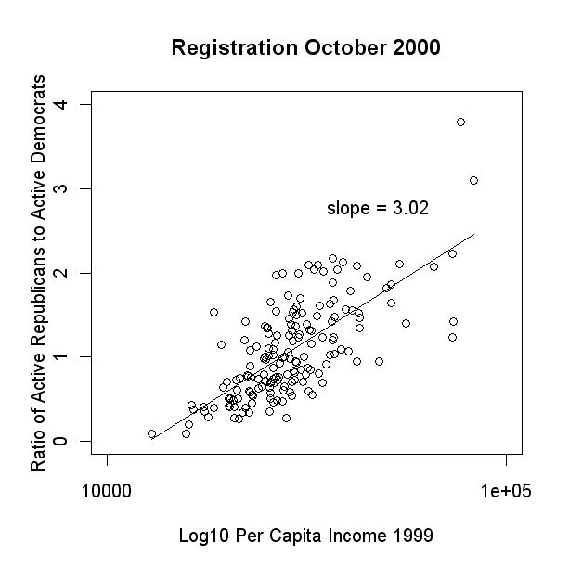 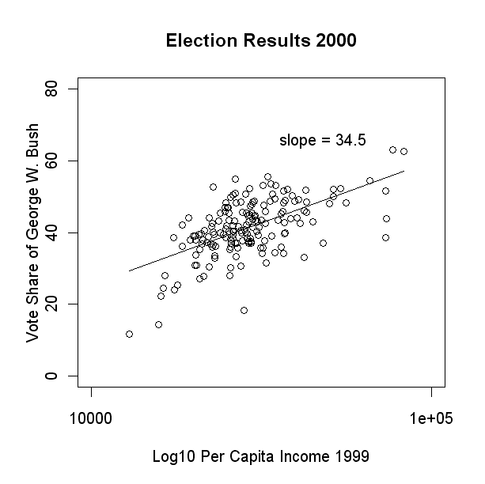

Now plotted against our measures for Traditionalism and Localism (Figures 3 and 4), a different pattern emerges. **(That is, I didn’t include these graphs because NO PATTERN emerges – ugh).** Basic OLS results show that only after adding these variables does Gelman’s pattern emerge. Two immediate conclusions can be made: 1) Connecticut cannot be treated as a totality where voters behave roughly like each across the state, and 2) Dropping the level of analysis by one or two geographic units (from state to counties, counties to towns) reveal fractal patterns where the relevance of income to voting is reproduced, but whose effect becomes increasingly attenuated by location-specific factors.[6]

Figure 3. GIS map of 2000,2004, 2008 Traditionalism/Localism by town

Figure 4. Traditionalism/Localism vs. registration/votes on same plot for 2000

(Adler 2007, Westport Minuteman)

The first is a map of George W. Bush’s vote share in the 2000 election

Kincaid and Lieske (1991)

Look also at Morrill (1998, 2007)

## From Marketing Base to Political Base: Tastes as preferences

The story above of Martha Stewart’s Connecticut connection serves to contextualize what became a national media empire. Doing so provides a concrete example of the geographic discontinuities present in American culture. While nationally syndicated and impactful of American decor as a whole, there are certain people and places where Martha Stewart finds a more receptive audience than others. More to the truth, there are many people who have dismissed her Waspish vision of the American home as either disturbing, out-dated, or both. What determines who embraces this aesthetic and who rejects it? What could this possibly say about these people’s political preferences? The link between the two lies in the context of their tastes, what is palatable and what is not. As a pre-reflexive guide to our experience in-the-world, these tastes color our preferences before we even begin to consciously decide them (Gerber and Green Partisan Hearts and Minds). And what, besides marketing research or survey analyses, can tell us what these tastes are? These are the questions we now want to answer, given the breakdown of a homogeneous state body politic and the interstitial importance of historical factors.

Simply put, the answer we propose to these questions is just: Scenes. We now consider several hypotheses about how the aesthetic choices accompanying different Scenes lead to logical affinities between the constituents of American political parties and the environments in which voters live.

Core Voting Model

In what follows, the dependent variable of interest is the proportion of votes cast for George W. Bush in the 2000 Presidential Election. We are not claiming that this election is archetypical of modern Presidential races, nor are we claiming that our hypotheses are more relevant to this election over others. Rather, like many analyses of electoral politics since 2000, the dramatic and somewhat surprising election results of this race provide a useful referent for understanding how our theory of Scenes and politics works in practice. Scholarly debate over the role of ‘values voters’ in this election and the partisan divide embodied by Red States and Blue States provide a serendipitous backdrop for showing the relevance of Scenes to electoral outcomes.

The unit of analysis for our voting model is always, in some way, the county. Specifically, we focus on the counties comprising the lower 48 states, excluding Alaska and Hawaii as too economically and socially distinct for comparison. In the case of Alaska, investment dividends from the Alaska Permanent Fund (totaling approximately $2,000 per Alaskan) are a unique economic context compared to the rest of the United States. Additionally, vast areas of Alaska contain such low population density that Census-designated areas are little more than a statistical construct. In the case of Hawaii, we assume that a tourist economy combined with nearly half the population being comprised of either Asian Americans or Pacific Islanders produces an electorate which would be difficult to readily understand, let alone compare to other areas of the country. In both cases, Hawaii and Alaska are physically and culturally disconnected from the rest of the country owing to their respective histories. As such we leave analyses of their electoral behavior to others.

Use of counties for our unit of analysis is both progressive and problematic. The progress comes from abandoning states as the unit of analysis. The problem comes from the fact that abandoning states as the unit of analysis means we cannot realistically incorporate individual survey data into our quantitative models.[7] As a result, our claims are modestly framed in terms of context. The importance of the contexts we present lies in their very existence as *physical* contexts rather than socioeconomic, religious or ideological contexts. To demonstrate that Scenes have similar relevance we have had to decide whether and how to control for these other contexts. For Presidential vote share, this requires a suitable core voting model embodying these and other factors, to which we can add Scenes.

After reviewing predictive models for the 2000 Presidential election, we opted to mimic the approach of Bartels and Zaller (2001). There were two reasons for this choice. First, it works reasonably well (predicting over 50% of the variance with a single economic indicator). Erikson et al. (2001) show that such models can be improved significantly with the addition of Presidential approval data, but the necessary data would only be available at the state level at best. The second reason we adopt this approach is our ability to construct an economic indicator which mimics their indicator, except in a cross-sectional analysis rather than the original longitudinal analysis. Their indicator, Real Disposable Income (RDI), proves to outperform the traditional indicator, Gross Domestic Product (GDP), by a wide margin. While calculating RDI at the county level is impractical if not impossible, a similar measure already exists as part of the Census: Gross Rent as a Percentage of Income. This measure fails to include tax burden and the cost of necessities, but it represents a significantly better conceptual measure of economic health than personal income, household income or rent alone. Thus we adopt Median Gross Rent as a Percentage of Income over Median Household Income as our economic indicator of a county’s relative wealth. To control for absolute differences, we also include Median Gross Rent. Together these variables should help discriminate areas with a higher cost of living and low discretionary income from those with a lower cost of living and low discretionary income. This becomes especially important in the context of urban centers, thus this approach should be a partial proxy for other measures such as population density which capture urbanity but not necessarily economic conditions.

In addition to these economic indicators, we add a number of relatively conventional measures to our core voting model in order to account for well-known effects. First, we include the average unemployment rate for the 12 months previous to the election. This fleshes out the economic picture by providing a measure of the health of a county’s labor market. Second, we include proportion of African Americans, in order to control for their historic support of Democratic candidates. Next we include proportion of retirees (population aged 65 and older), who historically heavily factor Republican candidates. Finally, we include two simplistic measures of religion: the number of religious adherents per 1000 population and the proportion of adherents belonging to self-identified Evangelical denominations. This results in the following specification:

$$Y_{t}=α+β_{1}x_{t,1}+β_{2}x_{t,2}+β_{3}x_{t,3}+β_{4}x_{t,4}+β_{5}x_{t,5}+β_{6}x_{t,6}+β_{7}x_{t,6}+ε_{t}$$

$$Y_{t}=\text{Republican Vote Share }\left(\text{2000}\right) \\ x_{t,1}=\text{Median Gross Rent as \% Household Income (1999}\text{)} \\ x_{t,2}=\text{Median Gross Rent (2000}\text{)} \\ x_{t,3}=\text{Average Unemployment Rate (}{\text{11}}/{\text{1999}}\text{-}{\text{11}}/{\text{2000}}\text{)} \\ x_{t,4}=\text{Proportion African American (2000}\text{)} \\ x_{t,5}=\text{Proportion Over 65 Years Old (2000}\text{)} \\ x_{t,6}=\text{Religious Adherence Rate (2000}\text{)} \\ x_{t,7}=\text{Proportion Evangelical Adherents (2000}\text{)}$$

The possibility of adding a time-lagged variable for Republican vote share was considered, but ultimately rejected on a number of grounds. Specifically, such a lag variable should ideally be estimated through a separate regression with all current independent variables lagged a similar time period. This is beyond the scope of the current project, and introduces significant methodological challenges given the variables of interest – Scene Performance Scores. These scores are based solely on 2001 County Business Patterns (CBP) data and uses the NAICS system for classifying businesses. Similar data are available in the 1996 CBP data, but are based on the SIC classification standard. This renders the two effectively incomparable at the present time.[8]

### The Martha Stewart Demographic

1. The Martha Stewart demographic (MSD) will tend to be composed of traditionalistic and locally oriented individuals. This demographic includes women as well as their husbands as we assume that the cultural aesthetic of the former reflects that of the latter. We further assumes that the underlying market audience for Martha Stewart is women who have the time and/or desire to undertake the projects that she presents. For our purposes, this encompasses women who are married and not in the workforce, women who are employed in the service industry, and married women who are unemployed.[9] This receptivity to Martha Stewart’s version of Americana will in turn reflect receptivity to Republican candidates who appeal to similar idealizations of America and its past. The effect should be enhanced when these women live in areas which are more traditionalist and local, since this provides a context more aligned with Martha Stewart’s vision (as she herself has described it). We expect that this effect will be larger in the Great Plains and Mountain West parts of America, owing to their particular history tied to Manifest Destiny.

Rationale: A major part of modern Republican political platforms has always been a combination of rugged individualism and recognition of the greatness of American culture. Members of the MSD are individuals attracted to the vision of Americana and hospitality which Martha Stewart has branded. This attraction arises either naturally (through living in areas more oriented toward an ideology of rugged individualism and America-first) or abstractly (through the adoption of this ideology). In both cases, an affinity between the MSD and Republicanism arises from the desire to reinstitute or maintain a vision of America which returns to an ideal point in American history. Fetishizing this time period (whether Colonial, Western or the Post-War years of the 1940s and 1950s) produces an aesthetic which can be capitalized upon, both economically and politically.

This hypothesis attempts to generalize the specific notion of Martha Stewart’s vision of what Westport was and what it meant to her. Her success is difficult to explain without positing an underlying aesthetic sense which others across the country also share. Without it she could not have enjoyed such business success. As such, we move beyond pure marketing research and into substantive social science, constructing a theoretical basis for the propensity of individuals to have this view of the world. Rather than searching for a demographic, we have defined one: The set of households which should be receptive to Martha Stewart’s vision of Americana.[10] We now test the extent to which areas with higher concentrations of these individuals have higher levels of Republicanism.

Hypothesis 1a: Areas with higher concentrations of the Martha Stewart Demographic will exhibit higher vote share for a Republican presidential candidate than areas with lower concentrations.

Hypothesis 1b: The Martha Stewart Demographic will have a larger positive effect on Republican vote share in more Traditionalistic and Localistic areas.

Broad support for Hypothesis 1 can be found in **Table 1**, the linear models performed on the entire set of U.S. counties for which we have data. Both the dummy variable, corresponding to a discrete Martha Stewart demographic context, and the index itself have a positive and significant relationship with Republican vote share in the 2000 Presidential election. The same set of robust regressions provides mixed but significant support for Hypothesis 2. While the discrete context seems unattenuated by more Traditionalistic and Localistic Scenes, the index itself shows the expected positive interaction with these Scenes.

To check for consistency, similar variables were employed in robust regressions on subsets of the original data corresponding to “high” and “low” values on the index. Unfortunately, the set of unpooled linear models constructed to test these hypotheses do not seem to suggest the same relationships. **Table 2** summarizes these models and reveals the distinct need to move beyond completely pooled and completely unpooled modeling techniques. All that can be reasonably said from these results is that the two modeling strategies produce different results. This is evidenced by the fact that (for example) Religious Adherence Rates seem to have very different effects on Republican vote share in the two subsets. Relationships exist which are censored by the completely pooled model, yet the completely pooled model represents the full sample. Thus we turn to multi-level techniques.

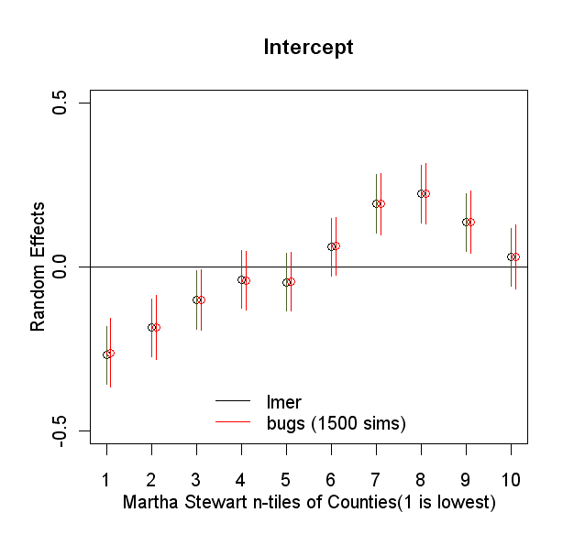

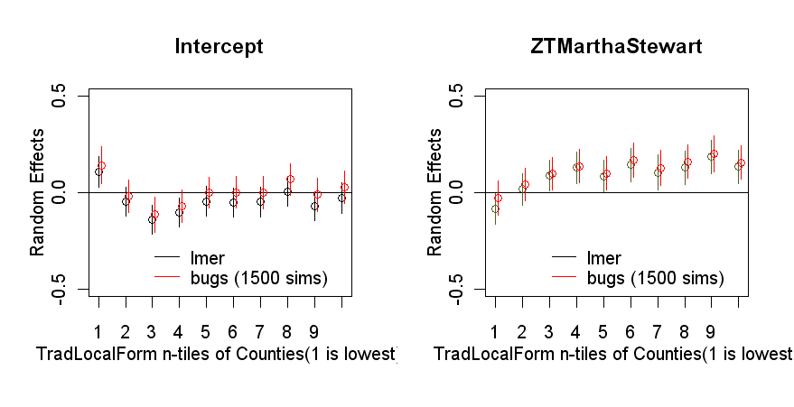

(multi-level testing next)

### Income and Republicanism in Three Scene Contexts

Income and Republicanism have a significantly different relationship in other Scene contexts, such as:

#### New Money Scenes vs. Old Money Scenes

New Money Scenes vs. Old Money Scenes: Highly traditionalistic, educated and wealthy areas, such as Memphis, TN, will have higher levels of Republicanism than highly transgresstive, educated and wealthy areas, such as New Haven, CT or Berkley, CA.

Republican support arises from multiple sources within the electorate, though it consistently correlates with higher income. We expect that this support among higher income individuals will wax and wane according to their cultural orientation toward wealth.

For example, the philanthropic civic participation of so-called “Old Money” families represents an approach to many social problems which fits quite well with Republicans’ policy of privatizing government services. Wealth comes with *noblesse oblige* and a public role. On the other hand, individuals who have become the “New Money” of America are less concerned with taking the reins of social problems than they are with distributive justice. Wealth is private, but society needs to guarantee that everyone gets what he/she deserves. This means protecting the rights of the wealthy to retain their wealth, but also protecting the rights of the poor in the workplace and the rights of all consumers in general. The goal is still to minimize waste and increased taxation of the wealthy, though this becomes weighed against the assumed the role of the government as an equalizer of the playing field.

While both exhibit New Political Culture mentalities by supporting fiscal responsibility, the social justice platform of the Democratic Party ought to decrease support for Republicans among New Money individuals. Scenes help identify New vs. Old Money by giving context to wealth. Through this tool we make a distinction between the Bourgeois Bohemian population described by David Brooks and what Gelman describes as rich voters in poor states, but without resorting to states as a geographic unit.

Hypothesis 2a – Money: Areas with higher proportion of households receive capital income (interest, dividend or rental income) will tend to support a Republican candidate for President.

Hypothesis 2b – Old Money: When more Traditional Scenes are present, support for a Republican candidate for President increases.

Hypothesis 2c – New Money: When more Transgressive Scenes are present, support for a Republican candidate for President decreases.

These three hypotheses are tested via the robust regressions presented in **Table 3**and **Table 4**. The reference dummy category of Models 1a/1b in **Table 3** is the set of counties with a high proportion of interest, dividend or rental income in 1999, but which are not Old Money or New Money. As such, all we can conclude from these two regressions is that New Money counties tended to have lower Republican vote share in 2000. While only significant at the a = 0.1 level, this is the only non-null result this discrete categorization of counties has produced. Thus we only find weak support for Hypothesis 2c.

Turning to Models 2a/2b in **Table 3**, a pattern contrary to all three hypotheses emerges. First, there is no significant impact of a county’s propotion of household income from interest, dividend and rental income in 1999 on Republican vote share. Second, a weakly positive relationship between Transgressive Scenes and Republican vote share seems to be significant at the a = 0.1 level. Finally, no relationship seems to exist between Traditional Scenes and Republican vote share. Worse, the interactions between Scenes and our measure of capital income are also insignificant.

While the completely pooled models fail to support our hypotheses in large part, looking at the unspooled models in **Table 4** reveals underlying patterns which are more hopeful. First, while the idea that capital is associated with higher levels of Republican vote share is again rejected by an insignificant constant, it appears that within the Money context our core voting model changes dramatically. For instance, the effects of Evangelicals, religious adherence rates, median gross rent and proportion African American are all exacerbated. Unfortunately this may also be due to the significantly smaller subset of counties this represents compared to the full sample. Tentatively, then, Hypothesis 2a is in grave doubt.

Where the contextual effect of Money is doubtful, it is clear that differences exist between Old Money contexts, New Money contexts and the Base model. First, neither Old nor New Money counties show a relationship between religious adherence rates and Republican vote share. Second, Old Money counties show a less negative relationship between proportion of African Americans and Republican vote share. Third, New Money counties show a barely significant but definitely positive relationship between Median Gross Rent and Republican vote share. Overall, then, even if Hypotheses 2a-2c can be refuted we still know that differences in electoral behavior exist between these Scene-based county contexts.

These results, weak as they are in some cases and contradictive of our Hypotheses in others, can also benefit from the multi-level approach. (insert here)

Beyond these direct relationships between Scenes, capital income and Republican voting, we further expect Old and New Money to intervene in the overall relationship between income and Republican voting. Specifically, the Old Money perspective holds that personal wealth benefits society. Thus such areas with wealthier individuals will value fiscal austerity as both personally beneficial and responsible governance, implying greater support for a Republican presidential candidate. Alternatively, the New Money perspective holds that personal wealth is earned, but does not necessarily benefit society. Thus such areas with wealthier individuals will value fiscal austerity as personally beneficial but not necessarily responsible governance. As a result, wealthier New Money areas are less likely to support a Republican candidate for President. In either case, poorer individuals are less likely to retain the economic perspective of what might be called a capitalist in this schema, and thus much less likely to support a Republican for President.

Hypothesis 3a: Old Money areas where individuals have more disposable income will be more likely to vote for a Republican presidential candidate, compared to areas with capital income in general.

Hypothesis 3b: New Money areas where individuals have more disposable income will be less likely to vote for a Republican presidential candidate, compared to areas with capital income in general.

Turning again to Table 4, we actually find evidence of the reverse relationships suggested by Hypotheses 3a/3b. Comparing the New Money and Old Money Models to the Money Model we find that the positive coefficients for disposable income are greater for New Money than Money, and lesser for Old Money than Money. (Reasons why? Possible instant-gratification trumps moral calculus in transgressive contexts?)

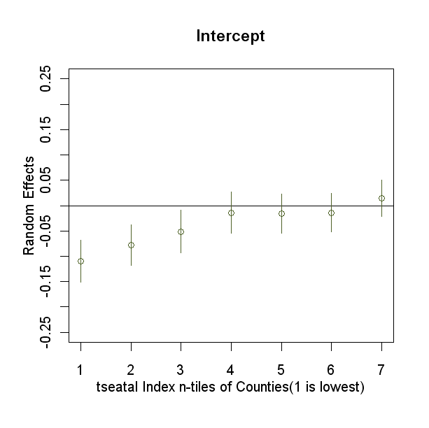

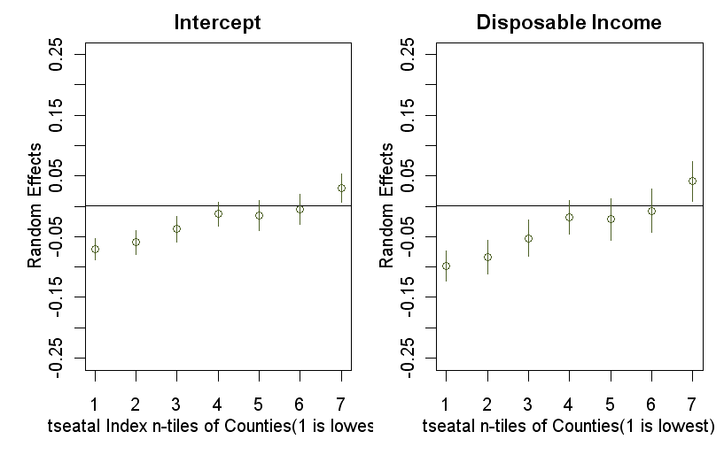

#### Lower Income Scenes

**Lower Income Scenes**: Counties with less disposable income and low education with highly Traditionalistic, Localistic, Neighborly and Informal Scenes will exhibit higher levels of Republicanism . (TO BE WORKED ON)

The voters of interest in Thomas Frank’s “What’s the Matter with Kansas?” can be roughly described as low income and education individuals with conservative beliefs regarding how the economy and society should behave.[11] Supposedly, Republican politicians appeal to these beliefs in order to attract support from this demographic, even though the candidate’s policy platform is detrimental to their economic well-being. Frank’s analysis lacks significant statistical evidence of his hypotheses, instead substituting it with what he hopes is sufficient journalistic evidence to prove his point. There are many obstacles to actually performing the statistical analyses necessary to test his hypotheses, but we believe that Scenes can help differentiate between different kinds of lower income areas. Additionally, Gimpel and Karnes (2006) conclude that “In spite of prevailing low income, [rural Americans’] individualistic ethic and legacy of self-employment and home-ownership inclines them to adopt the self-image of the independent entrepreneur and property owner rather than that of the laborer in need of state regulation and protection,” leading us to believe that Scenes have the possibility of refining the clumsy category of ‘rural voter’ into something meaningful.

Rather than assuming that these voters are being misled or manipulated into acting against their economic well-being, the more salient question for research is what these individuals consider to be their political interests. Gelman et. al’s response to Frank was that these people *believe* they are acting in their economic interests, thus they aren’t voting against their interests, and so not being manipulated. This only returns the debate to the realm of false consciousness, how and to what extent its presence can be seen. Setting Marxist notions aside, the pertinent question remains: What compels these individuals to vote Republican? One answer, from the Scenes perspective, is to suggest that an appeal by politicians to a particular way of life outweighs an appeal by politicians to particular issue-positions.

This might appear to be an attempt to quantify charisma, complete with images of George W. Bush in a cowboy hat and a somewhat convincing scatter-plot, but this would be misinterpreting the relationship between private individuals, public individuals, and Scenes. We have posited a Charismatic Scene already, one which values individual displays of publicity. This may attenuate the effect of political appeals by individuals such as politicians, but this is not the same as an appeal to a way of life – unless that way of life is based on larger-than-life individuals, which is possible. Rather, the effectiveness of projecting a political platform as the extension of the American way of life relies entirely on voters’ concept of the American way of life. This underlying image, sometimes understood as the American Way, represents a susceptibility to the appeals made by particular politicians trying to project their own image of the American Way.

To hone in on Frank’s Kansan voter, we consider a number of factors. First, he is explicitly interested in low income/education voters. Second, he attributes their behavior to moral appeals by politicians. Third, Scenes represent underlying beliefs about the world. Together we can create two ideal typical voters: 1) A low-income/education voter whose Scene is consonant with a Republican platform, 2) A low-income/education voter whose Scene is dissonant with a Republican platform. Determining which Scenes are consonant or dissonant is possible by considering this platform for a given election year.[12] For the 2000 Presidential election we are able to reconstruct a somewhat rigorous picture of the candidates’ platforms, owing to the Wisconsin Advertising Project. The Project painstakingly evaluated the content of various advertisements in the 2000 election cycle, matching them to frequency data which allows researchers to determine when and where an ad was broadcast. The variable of interest from this data is one which asks the question “Does the ad use any of the following adjective to characterize the favored candidate?” and provides 23 different possible adjectives.[13]

To construct a Scenes profile of the constituents that candidates were directing their message, we assumed that the most important adjectives were broadcast most often. Thus a mention of a candidate being a ‘reformer’ in one ad and being a ‘fiscal conservative’ in many ads would indicate that a candidate was pushing an image/platform of fiscal conservatism more than an image/platform of areform. Aggregating this frequency data produces the overall image a candidate was trying to project. We consider this image, and then explain which Scenes should be most receptive.

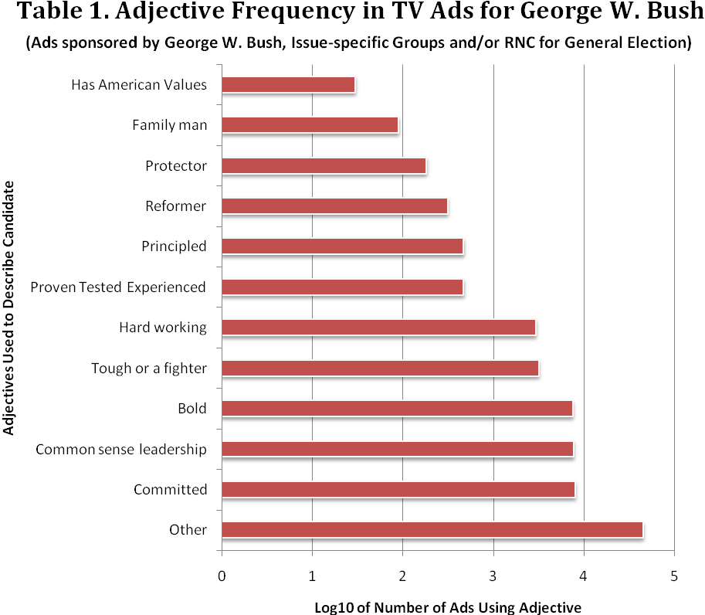Focusing on the Republican side of this story, in Table 1 we can see the relative distribution of adjectives used in broadcast ads for George W. Bush in the General Election. We can see that ‘bold’, ‘common sense leadership’ and ‘committed’ stand out as particularly important aspects of the image his supporters wanted to project. To make the connection between this and Scenes, however, it’s important to consider the nuances of this image. For instance, being a reformer and being principled are broadcast less than being tough or hard working.

This leads us to describe Bush as appealing to ***Traditionalistic, Local Neighborly and Informal Scenes***. Such a conclusion might be made based on any number of cues, such as Bush’s speaking and argumentative style during interviews and debates, but this data gives further evidence that these cues were part of a larger, coherent message: George W. Bush is a rugged individual who will take charge, work hard, and find common sense solutions to America’s problems. It’s important to note that this image is relatively neutral regarding religion or specific moral claims, something which many have claimed to be a significant part of the reason why low income/education individuals voted for Bush. In fact, our goal is not to decide which specific messages helped Bush to win the election, but rather the cultural context which he constructed for himself, and how this context might be important independent of the message.

Hypothesis 5a: Areas with lower proportions of people who have been to college, and with less disposable income, vote increasingly for a Republican presidential candidate.

Hypothesis 5b: Hypothesis 5a is only valid where there exists a Scene consonant with the Republican presidential campaign’s paradigm describing the candidate.

To test these hypotheses we turn to **Table 7** and **Tables 8a-8c**. Table 7 illustrates the danger inherent in generalizations such as Frank’s. Strong evidence persists in all models that while education is negatively associated with Republican vote share, disposable income is *positively* associated. Thus Hypothesis 5a, based on Frank’s work, is half right and half wrong. Interestingly, our Scenes hypothesis based on the Bush Index appears to provide the added nuance necessary to reveal what Frank was trying to show. That is, the Bush Index in itself appears to be unrelated to Republican vote share, but its interaction with income and education are both significant and negative. The more that a county’s average Scene was consonant with the way of life referenced by the Bush campaign, the more that county exhibited a negative relationship between education/income and Republican vote share. Frank thus appears vindicated, though without any of the ideological trappings he attempted to put forward as explanation.

Comparing these fascinating results from the completely pooled models, the completely unpooled models provide mixed support for our initial conclusions. **Table 8b** in particular seems to suggest that the effect of the Bush Index is categorically different for low/high income/education. Not only is it different, but it appears most significant for high education counties – even as the net effect is positive for high income counties and *negative* for low income counties. One strong technical possibility for this confusion is the great variation in the adjusted R2 of the unpooled models. It may simply be that within the subset of low income, low education counties the core voting model performs very poorly. The only feasible way to address the mismatch between pooled and unspooled models is to again consider what a multi-level model tells us in this situation.

**Figure #. Random Effects for Cross-Classified Multi-Level Model, Education n-tiles**

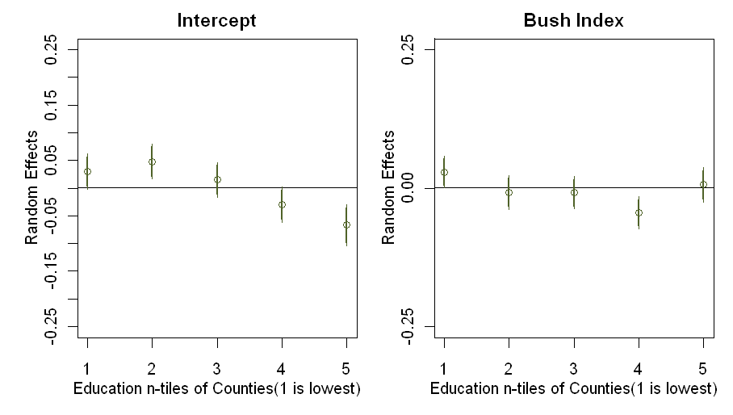

Initial results examining the random effects portion of multi-level model for Republican vote share in the 2000 Presidential election generally reinforce our initial findings. As we can see, the Bush Index has a positive relationship with Republican voting in the lowest education n-tiles, an effect which reverses as counties have a context of higher average education. One unintuitive result, however, is the positive trend between the context of average educational level and Republican vote share, though this agrees with the classical linear regressions reported above. We next term to n-tiles of income.

**Figure #. Random Effects for Cross-Classified Multi-Level Model, Disposable Income n-tiles**

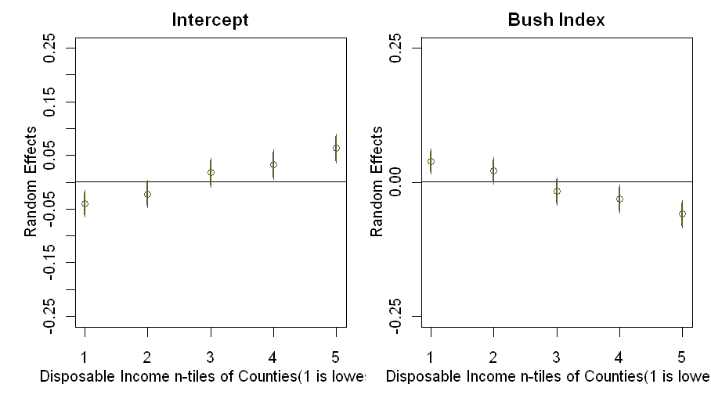

Again, initial findings are confirmed. Counties where Scenes consonant with the Bush campaign’s message are associated with higher Republican vote share only in counties with less disposable income. In fact, the Bush Scene seems to have a negative association with Republican voting in counties with the most disposable income. Accompanying this trend is a more intuitive finding than for education: Counties with, on average, more disposable income also have higher than average Republican vote share while counties with less disposable income have less than average Republican vote share, relative to all n-tiles.

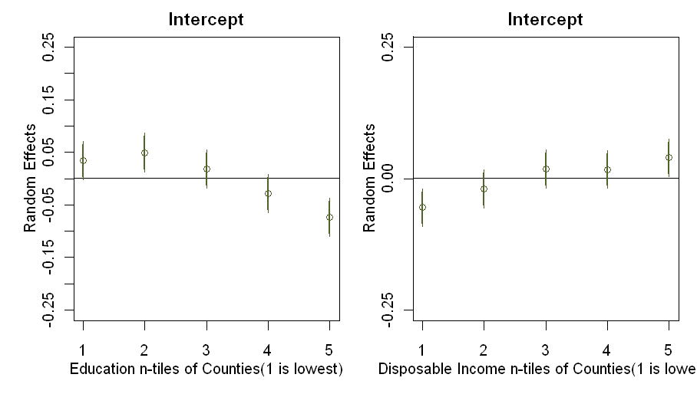

#### Middle-Class Scenes

* 1. Middle-Class Scenes: Counties characterized as middle-class will exhibit greater Republican vote share with less racial diversity, and vice versa. This relationship is robust with respect to the proportion of African Americans in the county (past a threshold of 10%), but the effect of diversity changes in the context of particular Scenes:
     1. Traditional and Ethnic Scenes will reinforce historic race relations, thus suppressing the positive effect of integration on Republican vote share.
     2. Untraditional, Rational, Corporate, and Transgressive Scenes will suppress the visibility of historic race relations, thus enhancing the positive effect of integration on Republican vote share.
     3. Combining these two constructs, we can consider the C.U.R.aT.aE variable (**C**orporatist, **U**tilitarian, **R**ational, **a**nti-**T**raditional, **a**nti-**E**thnic Scenes)

The importance of race in American politics is both significant and significantly complicated. To test a racially oriented hypothesis, it is important to put forward a context within which race is treated. In this case, the racial diversity of a county (as measured by the Index of Dissimilarity) provides the context in which we examine the relationship between income and voting. While the definition of the “middle-class” is highly disputed, we focus on income-based measures due to the complex occupational and educational structure of African American communities.[14] We chose two measures calculated by the Census Bureau from the 2000 Census, the income-to-poverty ratio and gross rent as a percentage of income.

The income-to-poverty ratio is calculated using the somewhat problematic standard of poverty thresholds. A value of two or greater is often considered an indication of middle-class income. In contrast, gross rent as a percentage of income is the “computed ratio of monthly gross rent to monthly household income (total household income in 1999 divided by 12). The ratio is computed separately for each unit and is rounded to the nearest tenth,” (Census 2000 SF3 Documentation file, pg. B-55). This data is presented both as an interval variable representing the median, and a series of discrete variables representing the number of renter-occupied housing units within a particular percentage range. We chose the latter group of variables in order to retain a sense of the underlying distribution. The added complexity of this second middle-class measure comes with the tremendous benefit of having an income-based variable based on the particular needs of a household. Further, it provides at least some insight into the relative amount of disposable income. For the purposes of testing effects involving the middle-class, however, we make most use of the fact that this variable exists for the racial categories of interest, something which is not the case of the income-to-poverty ratio.

We expect Scenic effects to affect the relationship between racial diversity and Republican vote share most strongly in middle-class areas for two reasons. First, both lower and higher income areas are economic contexts where class-status is more defined than in middle-class areas. Second, the middle-class represents an ideology of class mobility which is very frequently the centerpiece of political platforms. Policy is often framed with respect to the middle-class as the quintessential socioeconomic status of Americans. Specific to race, however, middle-class identity in the African American community is a contested research topic which consistently involves contextualizing individuals’ identities regarding group outcomes.[15] Including geography as a context has already been attempted (i.e. Gay 2004), but to our knowledge this has been survey-based and thus of limited geographic scope.

The role of Traditional, Ethnic, Corporate, and Transgressive Scenes is to imbue spatial contexts with a meaningful experiential component which goes beyond particular amenities, such as the presence or absence of amenities considered desirable for a community. Research on the political relevance of these amenities usually focuses on public policy implications, such as the health effects of food deserts (see Beaulac et al 2009 for a review) or economic effects of environmental amenities and urban sprawl (see Wu 2006, Bransington and Hite 2005). Rather than making a laborious connection between these relatively specific amenities and electoral outcomes, we use Scenes to understand the experience presented by the total human environment. For the county unit of analysis, we derive variables based on the mean Performance Scores of its zip codes. This represents the average experience of individuals within the county, a cartographic assumption we hope to relax in future work. For now, we compromise by also performing a multi-level analysis to compare the effects of zip code Scenes’ and racial contexts on county Republican vote share.

An important analytic issue to consider regarding Scenes is the possibility of racial Scenes. Theoretically, an individual’s race should have no impact on the effect of a Scene. This is due to the fact that Scenes are themselves containers for specific kinds of amenities, rather than these amenities themselves. Thus a Glamorous Scene cannot be tied to higher income areas since both high and low income areas have concentrations of hair dressers, barbershops, nail salons and the like. Glamour in itself is an orientation to one’s outward appearance, not any particular kind of appearance. Similarly, Traditional and Ethnic Scenes should *not* have a particularly racial component. Rather they represent the mere existence of a kind of environment, either focused on traditional mores or ethnic pasts. At the same time, the racial diversity of an area is likely to interact with an area’s Scene. Diversity provides an indicator of the homogeneity or heterogeneity of the individuals populating a particular Scene, and in turn what a Scene represents to these individuals. For instance, we have already posited that a neighborhood surrounded by golf courses, bed and breakfasts, and libraries is associated with different neighborly interactions than if the neighborhood when surrounded by Wal-Mart, Macy’s and FedEx/Kinko’s. This ought to be especially the case when one’s neighbors are of a different race.

**Hypothesis 4a**: Areas with more racial integration should see less of a negative relationship between the proportion of African Americans living there and vote share for a Republican candidate for president.

This is the first of two hypotheses inspired by Dawson (1994). Dawson describes a general condition for the decoupling of individual African Americans’ interests from the interests of the African American community as a whole. Specifically, he posits that “affluent African Americans with weak ties to the black community are more likely to have biased calculations in favor of the individual calculus,” (Dawson 1994). One interpretation of how this would work at the county level revolves around the presence of a geographically unified African American community. We thus use the traditional Index of Dissimilarity to measure the extent to which individuals are more likely or less likely to maintain political interests consonant with the collective as a whole.

The assumption here is that distance, regardless of population density, has a dissipative effect on the (political) unity of the African American community. This is in line with the cognitive mechanism which Dawson suggests as a driver of this decoupling:

[T]he availability heuristic suggests the reason for this [phenomenon]. The information obtained

by these African Americans would be drawn largely from their white colleagues. While such

information might include mixed signals about their own worth and achievements, it would also

convey the individualistic norms and values prominent among white citizens. These norms

would tend to bias the African Americans’ calculations toward the individual calculus. (Dawson

1994)

The definition of what constitutes a colleague is debatable, but the thrust of the availability bias is that individuals are only exposed to a limited set of information. Thus, even if distance were overcome by a strong social community, unless African American individuals work at largely African American operated businesses, frequent largely African American amenities and live in largely African American neighborhoods, they will be bombarded with information which undermines collective unity.[16] Put another way, Dawson’s concept of shared fate, by his own account, relies on a sufficient level of exposure to African Americans to retain its effect on individual beliefs in aggregate.

To test this hypothesis we performed robust regression on the core voting model, including two variables – one for the Index of Dissimilarity of a county in 2000, and one for the interaction between this variable and the log proportion of African Americans in 2000. Further, we should note that this analysis and all remaining analyses involving segregation were performed on a subset of counties with at least a 10% proportion of African Americans in 2000.[17] Model 2 in **Table 5** shows that the relationship between segregation and Republican vote share is actually more complicated than Hypothesis 4a assumes. By itself, residential segregation tends to decrease Republican vote share. At the same time, residential segregation combined with higher proportions of African Americans tends to increase Republican vote share. Thus Hypothesis 4a appears to be true, but only to the extent that the proportion of African Americans in the county remains low. Otherwise, the main effect is overwhelmed by the interaction. (Why this should be the case is up for discussion) The Low Segregation Models in **Table 6**seem to support this interpretation, indicating that in a context of residential integration higher average levels of Republican vote share exist (comparing constant terms).

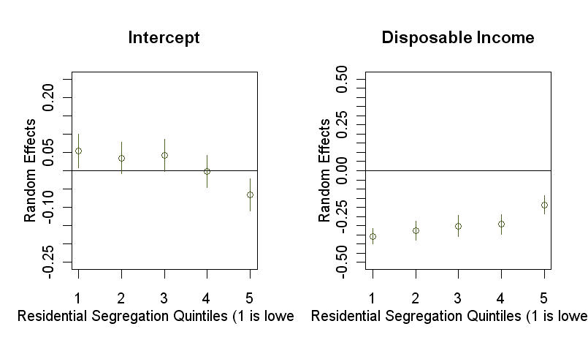

**Hypothesis 4b**: The effect of racial integration on Republican vote share should be more pronounced where an African middle class exists.

This is the second hypothesis inspired by Dawson (1994). It represents an extension of the first hypothesis, and its logic, by describing which kind of African Americans are most likely to be receptive to information which goes against traditional, collective political interests. In many ways it represents a simplistic view of new class cleavages within the African American community, a topic which has garnered significant interest even prior to Dawson’s writing. The utility of this hypothesis lies not in its ability to capture a specific phenomenon. Instead it provides a foundation for confirming a generic phenomenon which we can explore using the context of Scenes.

**Table 4** and **Table 5** imply that this hypothesis should be flatly rejected. At no point is the Black Middle Class significant.

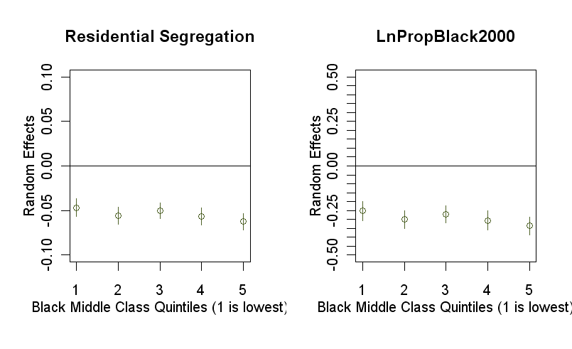

**Hypothesis 4c**: C.U.R.aT.aE Scenes enhance the effect of integration on Republican vote share, especially where an African American middle class exists.

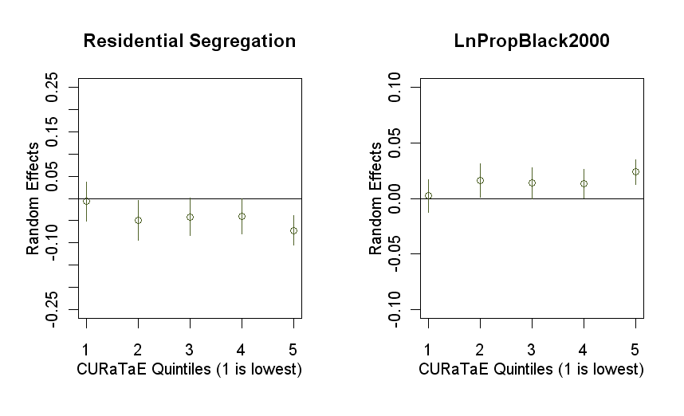

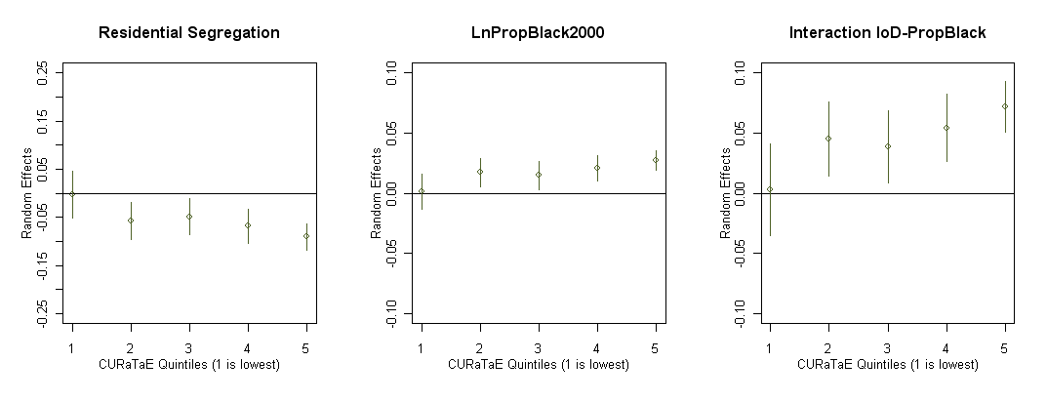

Here we leave purely socioeconomic contexts and introduce a cultural context. The logic is relatively simple: Traditionalist and Ethnic Scenes reinforce the historical context of race relations, thereby inherently reinforcing what Dawson calls the “transmission of historical information across generations” and thus suppressing Republican vote share further.This effect should be generally true regardless of economic status.

Conversely, a distinct lack of Traditionalist and Ethnic Scenes should enhance Republican voting in a middle-class context, as it allows middle-class African Americans to further distance themselves from the historical context of race relations. In this sense class differences should manifest themselves as individuals perceive their economic interests diverging from the economic interests of other African Americans. At the same time, the intergenerational transmission of information which that broadcasts African American interests and unifies the African American individuals is hampered by an environment which facilitates ahistorical and non-traditional interactions. Such a modern, rational and goal-oriented area would actively deemphasize race, especially in the presence of racial integration or low proportions of African Americans.

This hypothesis finds broad support even in the absence of the Black Middle Class as measured here. While **Table 5** shows that C.U.R.aT.aE Scenes have a net negative effect on Republican Voting, this effect interacts negatively with Index of Dissimilarity. Thus more residentially integrated counties with C.U.R.aT.aE Scenes exhibit higher Republican vote share.

Interestingly, the unpooled models of Table 6 actually imply that the negative main effect of C.U.R.aT.aE Scenes are only significant in the context of high segregation. (What this implies is up for debate)

Conclusion:

The picture which emerges above is one of ….. .

It is important to note that there is little reason to believe these hypotheses cannot be repeated on other racial, social or religious groups which maintain a similar kind of community-oriented politics. Obvious examples include Hispanic Americans, Evangelical adherents or Union members, though African Americans tend to represent the most coherent example of such political behavior. This makes them ideal for a national model, while other groups are more likely to have idiosyncrasies which make them significantly harder to generalize.

Variable Construction:

**Race variables constructed from 2000 Census in accordance to Logan et al. (2004)[18].**

White: White Only (non-hispanic)

Black: Black and Black with any other race

Diversity measure: *Index of Dissimilarity 2000* (black/white)

Level African American measure: *Ln Proportion Black 2000*

**Middle class defined (in total and by race) using both…**

***Income-to-poverty ratio 1999*** (>= 2.0)

Census: PCT050012

***Gross rent as a percentage of household income in 1999***[19] (10 categories, incl. Not Computed)

Census: White Alone: HCT39I, Black Alone: HCT39B

***Middle class***:

* + - 1. Dummy for income-to-poverty ratio >=2 and Median House Income in bottom 2/3rd of county.
      2. Middle third of Median Gross Rent as a Percentage of Household Income in 1999 (want to actually use categorical variable instead)

**Other**:

* + 1. ***College Degree 2000 for African Americans***
    2. ***Ethnic, Self-Expressive, Corporatist, Formal, Traditional***

Race and Scenes is Zip code!

Race, Scenes and Politics are County!

Analyses:

*Hypotheses regarding middle-class African Americans:*

1. **Middle-class African Americans living in predominantly middle-class white areas will suppress the historic pattern of African Americans voting for Democratic candidates.** 
   1. Directly from Dawson 1994, pg. 67:
      1. “affluent African Americans with weak ties to the black community are more likely to have biased calculations in favor of the individual calculus” … “the availability heuristic suggests the reason for this. The information obtained by these African Americans would be droawn largely from their white colleagues. While such information might include mixed signals about their own worth and achievements, it would also convey the individualistic norms and values prominent among white citizens. These norms would tend to bias the African Americans’ calculations toward the individual calculus.”
      2. “consider two middle-class individuals, one with strong ties to family and other black community institutions, the other *with the same household of individual utility function* but with very weak ties to the black community. The individual with strong ties to family and community will be slower to deemphasize racial group interests than the individual with weak ties because of the greater impact of information from the black community for that person.
   2. Thus: African Americans residing in majority white neighborhoods and having had some economic success (attainment/retention of middle-class status) are most likely to decouple from Democrat allegiances.

This implies a LESS NEGATIVE relationship between proportion African Americans and Republican vote share.

**County**: Average Ratio of Income to Poverty and Scenes, Median Gross Rent as %,

**Zip code**: Ratio of Income to Poverty, Median Gross Rent as % for Black/White, Scenes.

**Both**: Dummy for more whites than blacks.

Of interest: **Counties** with majority of **Zip codes with**…

Ratio White/Black > 2 and Income-to-Poverty >= 2

Ratio White/Black > 2 and Median Gross Rent as % for both are middle third of overall (want to use actual categorical variable instead)

*Hypotheses regarding Scenes*

1. **Traditionalist and Ethnic Scenes reinforce the historical context of race relations, thereby inherently reinforcing what Dawson calls the “transmission of historical information across generations” and thus suppressing Republican vote share further.** 
   1. More Traditionalistic/Ethnic Scenes lead to lower Republican voting.
2. **Conversely, a distinct lack of Traditionalist and Ethnic Scenes should enhance Republican voting in a middle-class context, as it allows middle-class African Americans to further distance themselves from the historical context of race relations.**
3. **The interaction of Rational, Utilitarian and non-Ethnic Scenes with integration (lower Index of Dissimilarity) should enhance Republican voting since it represents a relatively acultural neighborhood.**

# Our Strategies/Hypotheses:

## Meeting of 9/23/09

TNC excited at the prospect of using multi-level methods against Gelman. Outline of possible argument:

1. Connecticut is not the homogeneous Bobo state claimed.
2. Counties within Connecticut show diversity along political, economic and cultural lines.
   1. Descriptives
3. Counties within Connecticut share unexpected similarities with counties in other states which follow Gelman’s pattern.
   1. Possibility 1: Matching on traditionalism more important than matching on income.
   2. Possibility 2: Controlling for traditionalism we erase/suppress the effect of income on vote share.
4. Retesting claims at the county level – with the addition of Scenes – reveals patterns of Bobos, gives meaning to Frank’s cultural argument, and contradicts or suppresses Gelman’s results.

### Connecticut is not the Bobo state that Gelman implies

**… but rather has its own bourgeois and conservative history tied to the modern Republican party:**

* 1. William F. Buckley Jr.
     1. Parents moved to Sharon, CT shortly before he went abroad for schooling
     2. Attended Yale University
     3. Wrote *God and Man at Yale* while living in Hamden, CT
     4. Founded Young Americans for Freedom in Sharon, CT
     5. Supported Joe Lieberman for CT Attorney General, against Republican candidate
     6. Died at home in Stamford, CT
  2. Bush Dynasty
     1. George H.W. Bush grew up in Greenwich, CT, attended Greenwich Day School
     2. George H.W. Bush, George W. Bush and Jeb Bush all attended Philips Academy in Andover, MA.
     3. Prescott Bush, George H.W. Bush, and George W. Bush all attended Yale.
  3. Joe Lieberman
     1. Born Stamford, Ct
     2. Attended Yale University
     3. In 2006, lost Democratic primary, ran as an independent, garnered widespread support from conservative commentators (including Rush Limbaugh, Glenn Beck, etc.)
     4. Hawkish (sponsored the Iraq War Resolution in 2002, staunch supporter of Israeli protectionism)
     5. For school vouchers, supports No Child Left Behind but considers it underfunded
  4. Martha Stewart
     1. Moved to Westport, CT in the 1970s
     2. Restoring 1805 home uncovered her decorating abilities
     3. Catering business run out of basement led to publishing of multiple books.
     4. Home was model for set of Martha Stewart Living
  5. Ann Coulter
     1. Raised in New Canaan, CT
  6. Laura Ingraham
     1. Raised in Glastonbury, CT

Culturally conservative/traditional roots:

William F. Buckley Old Conservative guard, father of American Neo-Conservativism

Bush Dynasty Foil to Kennedy Dynasty of Massachusetts

Joe Lieberman Rejects some socially liberal positions, as well as Democratic party

Martha Stewart Made her living off of selling the Connecticut/NE “brand”

Ann Coulter Overt hatred of liberalism and Democrats, widely published

Laura Ingraham Conservative radio host, #6 radio show host in the country (2008)

### Geographic patterns within Connecticut

|  |  |  |  |
| --- | --- | --- | --- |
| Town | Zipcode(s) | County | FIPS |
| Stamford, CT | 069xx | Fairfield County | 9001 |
| Greenwich, CT | 06807, 0683x, 06870, 06878 | Fairfield County | 9001 |
| Westport, CT | 06880 | Fairfield County | 9001 |
| New Canaan, CT | 06840 | Fairfield County | 9001 |
| Glastonbury, CT | 06025, 06033, 06073 | Hartford County | 9003 |
| Sharon, CT | 06069 | Litchfield County | 9005 |
| Hamden, CT | 06514, 06517, 06518 | New Haven County | 9009 |
| New Haven, CT | 0651x | New Haven County | 9009 |

There are eight counties in Connecticut.

**Fairfield County is considered the richest – so why does it have such strong connections to neo-conservativism?**

*Gelman claims that party identification has become important again. What does voter registration look like in Connecticut?*

**Voter Registration in Towns with Historical Ties to Modern Conservative Movement\***

|  |  |  |  |  |  |  |  |  |  |  |  |  |
| --- | --- | --- | --- | --- | --- | --- | --- | --- | --- | --- | --- | --- |
|  | **2000** | | | | **2004** | | | | **2008** | | | |
|  | Registered Republicans |  | Registered Democrats | Ratio | Registered Republicans |  | Registered Democrats | Ratio | Registered Republicans |  | Registered Democrats | Ratio |
| Towns |  |  |  |  |  |  |  |  |  |  |  |  |
| New Canaan, CT | 6519 |  | 2104 | 3.10 | 6509 |  | 2192 | 2.97 | 6342 |  | 2734 | 2.32 |
| Greenwich, CT | 15653 |  | 7028 | 2.23 | 14614 |  | 7176 | 2.04 | 13607 |  | 9084 | 1.50 |
| Sharon, CT | 743 |  | 382 | 1.95 | 694 |  | 484 | 1.43 | 597 |  | 639 | 0.93 |
| Glastonbury, CT | 6570 |  | 6178 | 1.06 | 6367 |  | 6362 | 1.00 | 6111 |  | 7714 | 0.79 |
| Westport, CT | 6119 |  | 4959 | 1.23 | 5429 |  | 5349 | 1.01 | 4978 |  | 6495 | 0.77 |
| Stamford, CT | 15744 |  | 22674 | 0.69 | 14553 |  | 22329 | 0.65 | 13435 |  | 25100 | 0.54 |
| Hamden, CT | 5789 |  | 11578 | 0.50 | 5068 |  | 12977 | 0.39 | 4469 |  | 16297 | 0.27 |
| New Haven, CT | 3125 |  | 36193 | 0.09 | 2691 |  | 37628 | 0.07 | 2708 |  | 44915 | 0.06 |
| **Town Average** |  |  |  | **1.08** |  |  |  | **1.00** |  |  |  | **0.83** |

* Discounts Inactive party registrants

**Presidential Election Results in Towns with Historical Ties to Modern Conservative Movement**

|  |  |  |  |  |  |  |  |  |  |  |  |  |
| --- | --- | --- | --- | --- | --- | --- | --- | --- | --- | --- | --- | --- |
|  | **2000** | | | | **2004** | | | | **2008** | | | |
|  | Votes for Bush |  | Votes for Gore | % Bush | Votes for Bush |  | Votes for Kerry | % Bush | Votes for McCain |  | Votes for Obama | % McCain |
| Towns |  |  |  |  |  |  |  |  |  |  |  |  |
| New Canaan, CT | 6501 |  | 3516 | 62.7 | 6618 |  | 4180 | 60.7 | 5877 |  | 5187 | 52.8 |
| Greenwich, CT | 14905 |  | 12780 | 51.5 | 15830 |  | 14334 | 51.9 | 13937 |  | 16233 | 45.9 |
| Sharon, CT | 621 |  | 697 | 43.0 | 649 |  | 897 | 41.1 | 527 |  | 1010 | 33.8 |
| Glastonbury, CT | 7928 |  | 9134 | 44.2 | 8854 |  | 9971 | 46.3 | 7755 |  | 11767 | 39.2 |
| Westport, CT | 5590 |  | 8304 | 38.6 | 6063 |  | 9115 | 40.0 | 5342 |  | 10067 | 34.5 |
| Stamford, CT | 15159 |  | 27430 | 34.2 | 18866 |  | 27588 | 40.1 | 17510 |  | 31733 | 35.3 |
| Hamden, CT | 7833 |  | 16638 | 30.2 | 9990 |  | 17774 | 35.3 | 8531 |  | 19960 | 29.7 |
| New Haven, CT | 5160 |  | 28145 | 14.2 | 7175 |  | 30979 | 18.3 | 5098 |  | 39112 | 11.4 |
| **Town Average** |  |  |  | **41.3** |  |  |  | **46.4** |  |  |  | **41.7** |

Graphs to Add for CT analysis:

3 Scatterplots of Ratio Registration Rep vs. Dem versus Median Household Income 2000

Include line for 1 (equal proportions)

Include shaded region for mean and 95% confidence interval

Identify towns of interest

3 Scatterplots of % Republican versus Median Household Income 2000

Include shaded region for mean and 95% confidence interval

Identify towns of interest

(Possibly do each of these as a three “fin” graph, or at least the first with line for 1)

Single line plot for ratio and % Bush for towns of interest.

Graphs to Add for National analysis:

Possible strategy:

Show that Ho that counties within states behave coherently is false.

Show that Ho that counties across states behave coherently is true.

Treat zip codes or towns as Gelman individuals

Direct and interactive effects of Scenes and (say) education on income relationships.

Dan: Scenes as intervening, but it feels like an article (Gelman focused)

How do we deal with race, class, gender and national politics?

Scenes strengthen, weaken and transform these effects.

Example of CT illustrates this.

Showing how Scenes give continuity to national politics in ways that States/demographics alone do not. Politics are no longer completely local, but neither are they completely random.

Steve: Two kind of politics at play, central-periphery argument versus different organized nodes. Scenes illuminate non-political.

Link consumption to politics, watch out about getting diverted.

Don’t get lost in Gelman.

Rerun Gelman with 3000 counties instead of 50 states.



*Do these counties actually satisfy the conditions Gelman used to identify Republican, Democratic and battleground states?[20]*

No, three counties in 2004 were “battleground” counties – including Fairfield and Lichtfield.

*What about the towns of interest?*

New Canaan was Republican in 2000 and 2004. Greenwich was battleground in 2000. Greenwich and Glastonbury were battleground in 2004. Greenwich and New Canaan were battleground in 2008, with New Canaan having 52% for McCain.

*What about the DRM/Landslide distinctions by CMG and Bill Bishop?*

All are Democratic in 2000/2004. Only 2 are landslide Democratic counties in 2000, otherwise competitive (landslide defined by 20% or greater win), Hartford and New Haven.

### Comparing Connecticut counties to similar counties across the country

**(focus on Traditionalism)**

Find matching counties, using these variables:

1. Race (categorical based on %black)
2. Education (categorical based on percent bachelor’s or higher)
3. Region (4 divisions, but possibly splitting up the West into pacific and mountain)
4. Traditionalism (considered as a treatment variable, specifically high traditionalism)

Perform regressions:

DV: Republican vote share

IV: Income

Control: Traditionalism, Population

Matching on: Race, Education, Region

DV: Republican vote share

IV: Income

Split on: Traditionalism (high/low/null, decided by finding statistically significant departures from a score of 3)

Matching on: Race, Education, Region

In each case, matching counties under broad quantitative categories allows for either specific comparisons within categories or multi-level analysis between and within categories.

Stricter matching constraints are possible for more qualitative or basic comparisons. This gives up generalizability in order to obtain a few really good examples of variation within extremely similar counties.

### Reevaluating Gelman’s claims using counties instead of states

**…applying Scenes to suppress income effects and reveal cultural patterns.**

This is where we expand into other arguments, beginning from the picture that emerges when we repeat Gelman ignoring state boundaries and grouping counties according to other characteristics. First this is done to suppress income and reveal Brooks’, Frank’s or Putnam’s phenomena. Next we add our own concepts.

Archetypal counties:

Rich counties:

Delaware County, PA - Republican Stronghold from mid-19th century until 1992, Democrat in Presidential

elections ever since. Has Democrat U.S. Senators and House Representatives, completely Republican county officeholders.

Radnor Township

Fairfield County, CT – Wealthy, looks Democrat at the county level, actually has Conservative roots.

New Canaan

Greenwich

## Meeting of 10/14/09:

Differing elasticity regarding income – why is it different than gelman (who assumes 0)? Using Brooks, Frank to find socially liberal parts of Connecticut and will have a lower income elasticity. Try using education to transform elasticity of income? Education should be interacting with something else (aka scenes). Income, education, income x education. Do split halves on education? Highly educated people have smaller income/voting relationship. New Haven is Rockefeller Republicans – Bloomberg Republicans. What gives us a zero slope?

### Elasticity between income and voting/registration, on split halves, quartiles and quintiles of Education.

**Connecticut:**

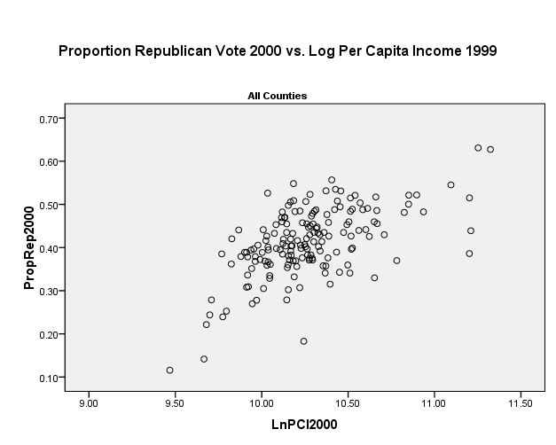

Split halves on Education (Left is low, Right is high)

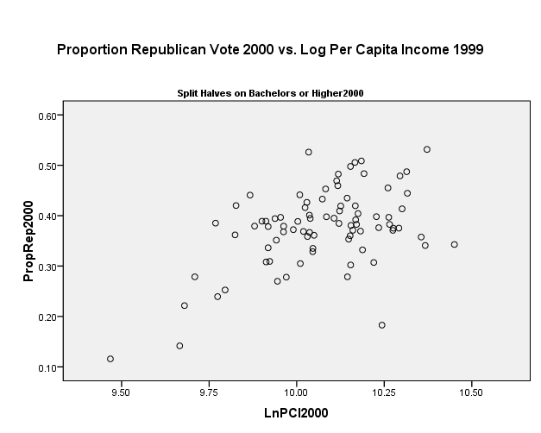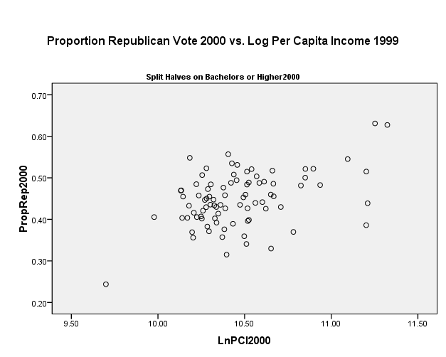

Thirds on Education (Left is low, Right is middle, Bottom is higher)

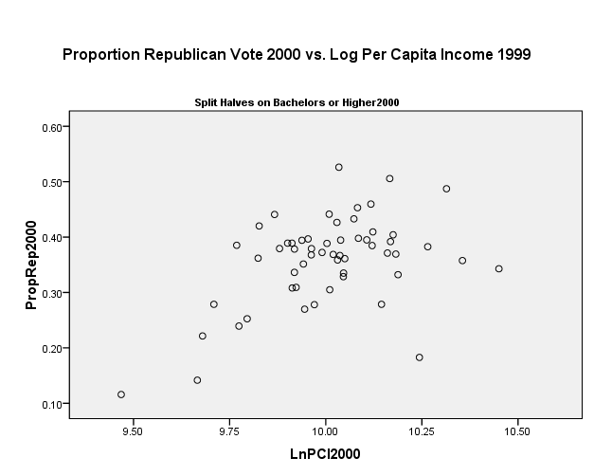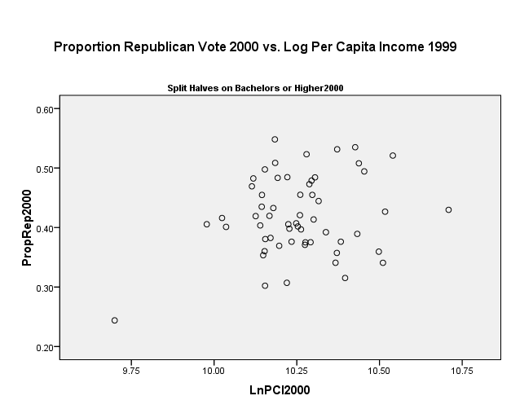

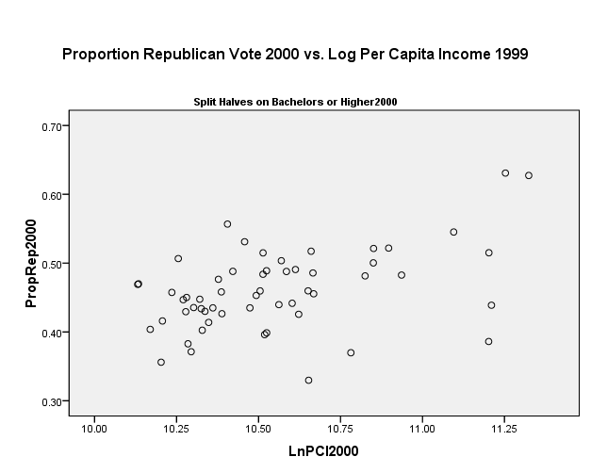

**Connecticut (N = 169)**

|  |  |  |  |  |  |
| --- | --- | --- | --- | --- | --- |
| n-tile of Education |  | **Thirds** | **High/Low** | **None** |  |
| **1** | **Correlation** | 0.466 | 0.49 | 0.59 | **Median Household Income (1999)** |
| *Sig. (2-tailed)* | 0 | 0 | 0 |
| **2** | **Correlation** | 0.222 | 0.448 |  |
| *Sig. (2-tailed)* | 0.097 | 0 |  |
| **3** | **Correlation** | 0.458 |  |  |
| *Sig. (2-tailed)* | 0 |  |  |
|  |  | **Proportion of Republican Vote (2000)** | | |

Conclusion: Education has little effect on the elasticity of income and Republican vote share in Connecticut. The same pattern persists when looking at the ratio of registered Republicans to Democrats.

**National**:

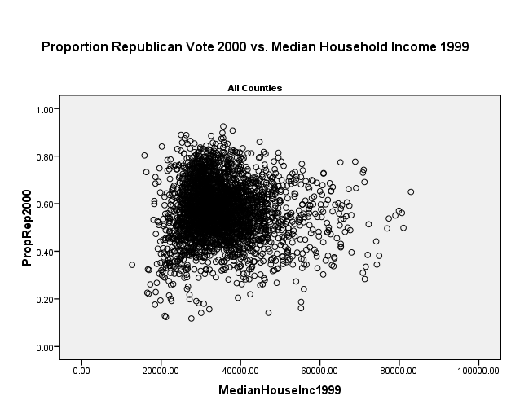

Split halves on Education (Left is low, Right is high)

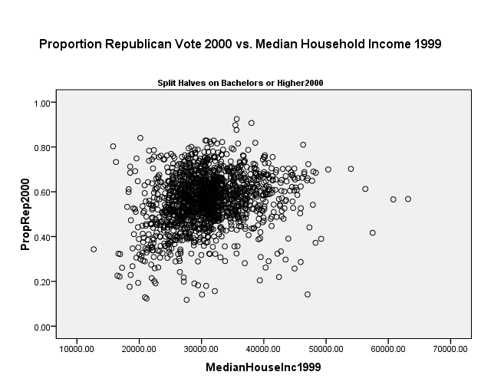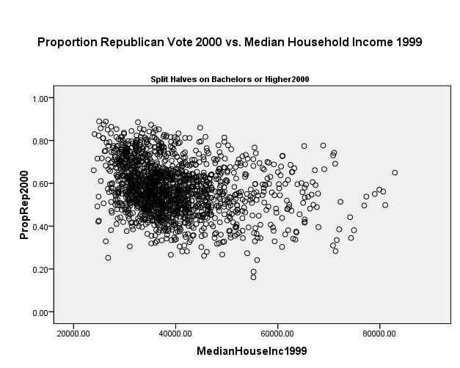

Thirds on Education (Left is low, Right is middle, Bottom is higher)

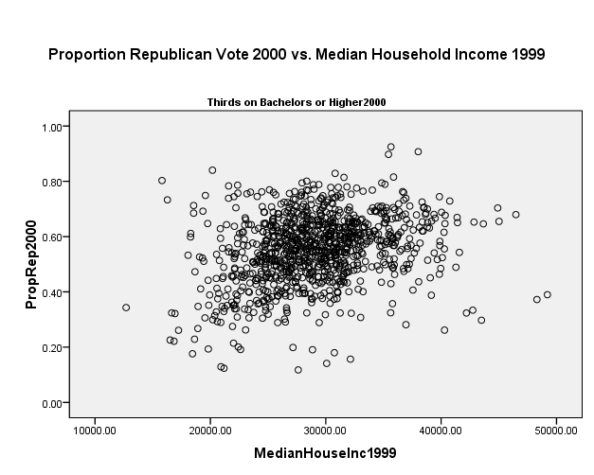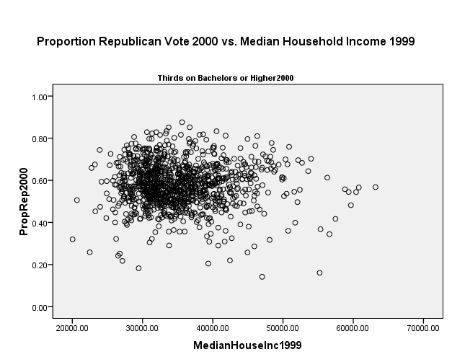

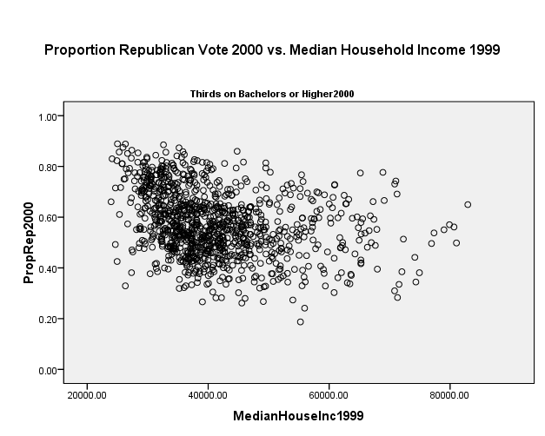

Quartiles on Education (Lowest to Highest: Left-Top to Right-Bottom)

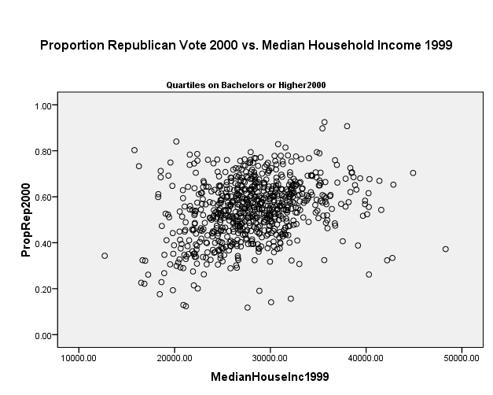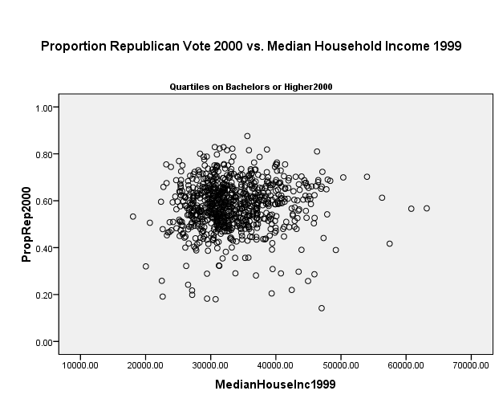

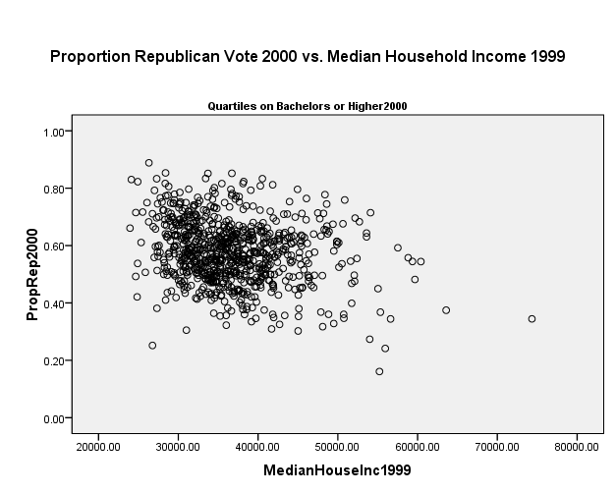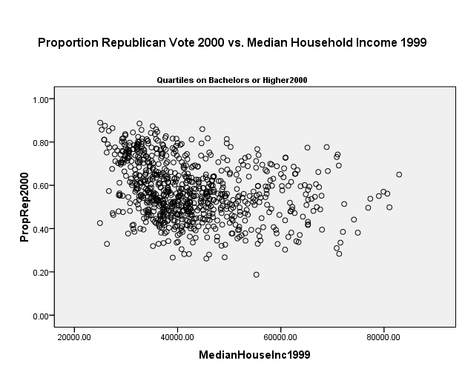

Quintiles on Education (Lowest to Highest: Left-Top to Bottom)

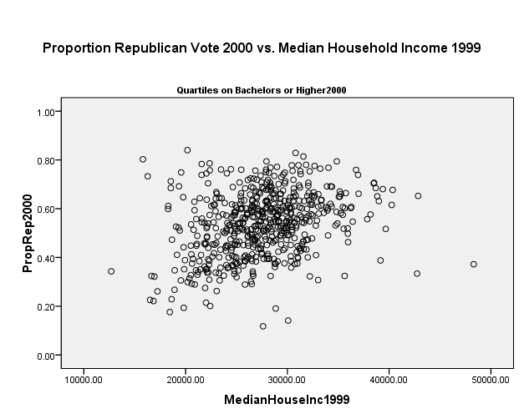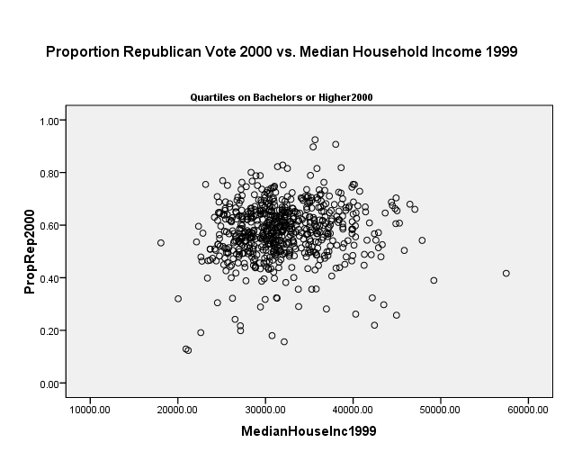

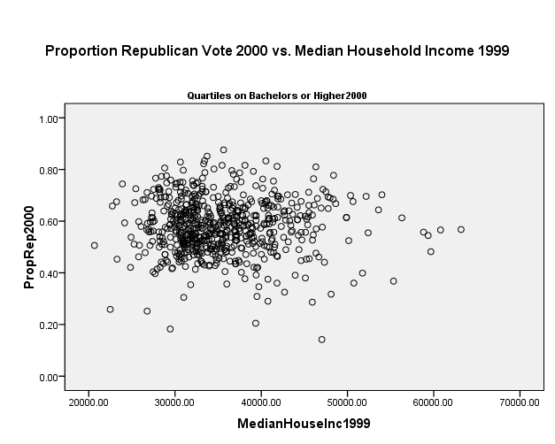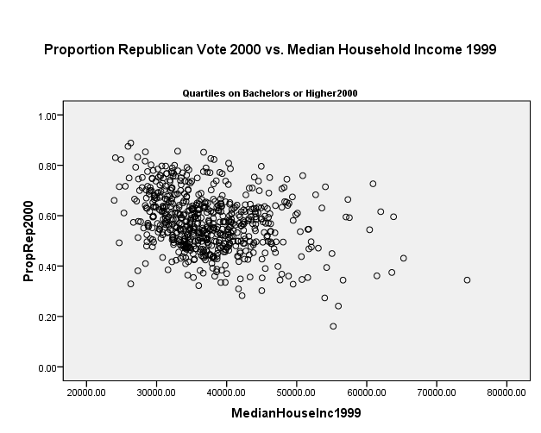

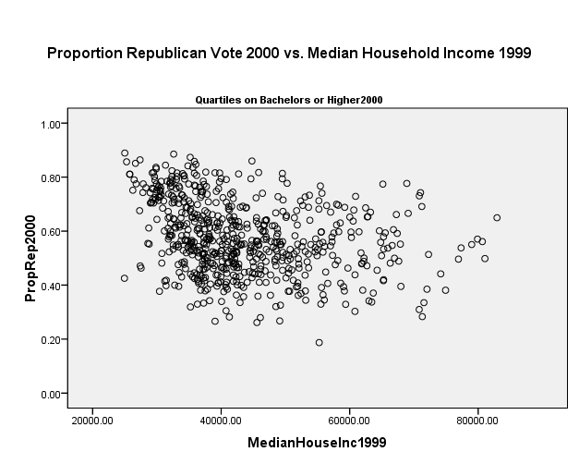

Table of Correlations (each column represents a different split along an n-tile)

**National (N ~ 3,100)**

|  |  |  |  |  |  |  |  |
| --- | --- | --- | --- | --- | --- | --- | --- |
| n-tile of Education |  | **Quintiles** | **Quartiles** | **Thirds** | **High/Low** | **None** |  |
| **1** | **Correlation** | 0.304 | 0.296 | 0.276 | 0.225 | -0.039 | **Median Household Income (1999)** |
| *Sig. (2-tailed)* | 0 | 0 | 0 | 0 | 0.031 |
| **2** | **Correlation** | 0.107 | 0.067 | -0.025 | -0.263 |  |
| *Sig. (2-tailed)* | 0.007 | 0.058 | 0.414 | 0 |  |
| **3** | **Correlation** | -0.013 | -0.237 | -0.308 |  |  |
| *Sig. (2-tailed)* | 0.752 | 0 | 0 |  |  |
| **4** | **Correlation** | -0.31 | -0.3 |  |  |  |
| *Sig. (2-tailed)* | 0 | 0 |  |  |  |
| **5** | **Correlation** | -0.309 |  |  |  |  |
| Sig. (2-tailed) | 0 |  |  |  |  |
|  |  | **Proportion of Republican Vote (2000)** | | | | |

Conclusions:

1. Overall there is a very slightly negative correlation between Median Household Income (2000) and Republican vote share (2000) among all counties in the US.
2. A high/low distinction of counties by Proportion of Bachelors Or Higher (2000) shows moderately negative/positive correlations respectively.
3. A pattern emerges beginning with thirds and extending into quintiles:
   1. Low overall education = positive correlation
   2. Average overall education = little to no correlation
   3. High overall education = negative correlation

The last implies that we can split into thirds and retain the overall pattern, but this will ignore the possible “hurdle” effect of education where the two lower quintiles have different negative correlations and the two higher quintiles have approximately the same positive correlation.

### Elasticity between income and voting/registration, with the linear additive/interaction of education and income?

**Connecticut**:

Just Per Capita Income

| **Model Summary** | | | | | | | |
| --- | --- | --- | --- | --- | --- | --- | --- |
| Model | R | R Square | | Adjusted R Square | | Std. Error of the Estimate | |
| 1 | .590a | .348 | | .344 | | .06463 | |
| a. Predictors: (Constant), LnPCI2000 | | | | | |  | |
| **Coefficientsa** | | | | | | | | | | |
| Model | | | Unstandardized Coefficients | | | | Standardized Coefficients | | t | Sig. |
| B | | Std. Error | | Beta | |
| 1 | (Constant) | | -1.127 | | .163 | |  | | -6.906 | .000 |
| LnPCI2000 | | .150 | | .016 | | .590 | | 9.441 | .000 |
| a. Dependent Variable: PropRep2000 | | | | | | |  | |  |  |

R^2 of 0.35

Log Per Capita Income and BachelorsOrHigher2000

| **Model Summary** | | | | | | | |
| --- | --- | --- | --- | --- | --- | --- | --- |
| Model | R | R Square | Adjusted R Square | | Std. Error of the Estimate | | |
| 1 | .649a | .421 | .414 | | .06110 | | |
| a. Predictors: (Constant), LnPCI2000, BachelorsOrHigher2000 | | | | | | | |
| **Coefficientsa** | | | | | | | | | | |
| Model | | | | Unstandardized Coefficients | | | Standardized Coefficients | | t | Sig. |
| B | | Std. Error | Beta | |
| 1 | (Constant) | | | -.750 | | .175 |  | | -4.289 | .000 |
| BachelorsOrHigher2000 | | | .544 | | .119 | .424 | | 4.568 | .000 |
| LnPCI2000 | | | .067 | | .024 | .262 | | 2.824 | .005 |
| a. Dependent Variable: PropRep2000 | | | | | |  |  | |  |  |

We see that the addition of Education suppresses and overtakes the effect of Income, also bumping R^2.

Interactions: BachelorsOrHigher2000, LnPCI2000 and their multiplicative interaction are all R > 0.75.

**United States**:

*IV*: Just Median Household Income (1999), *Dependent*: Republican Vote Share (2000)

|  |  |  |  |  |  |  |  |
| --- | --- | --- | --- | --- | --- | --- | --- |
|  |  | | | |  |  |  |
| n-tile of Education |  | **Quintiles** | **Quartiles** | **Thirds** | **High/Low** | **None** |  |
| **1** | **Beta** | 0.304 | 0.296 | 0.276 | 0.225 | -0.039 | Median Household Income (1999) |
| *Sig. (2-tailed)* | 0.00 | 0.00 | 0.00 | 0.00 | 0.03 |
| *R2* | 0.092 | 0.088 | 0.076 | 0.051 | 0.001 |
| **2** | **Beta** | 0.107 | 0.067 | -0.025 | -0.263 |  |
| *Sig. (2-tailed)* | 0.01 | 0.06 | 0.41 | 0.00 |  |
| *R2* | 0.011 | 0.004 | 0.001 | 0.069 |  |
| **3** | **Beta** | -0.013 | -0.237 | -0.308 |  |  |
| *Sig. (2-tailed)* | 0.75 | 0.00 | 0.00 |  |  |
| *R2* | 0.000 | 0.056 | 0.095 |  |  |
| **4** | **Beta** | -0.310 | -0.300 |  |  |  |
| *Sig. (2-tailed)* | 0.00 | 0.00 |  |  |  |
| *R2* | 0.096 | 0.090 |  |  |  |
| **5** | **Beta** | -0.309 |  |  |  |  |
| Sig. (2-tailed) | 0.000 |  |  |  |  |
| *R2* | 0.095 |  |  |  |  |

*IVs:* Median Household Income (1999) and BachelorsOrHigher2000

*Split Counties by BachelorsOrHigher2000*

|  |  |  |  |  |  |  |
| --- | --- | --- | --- | --- | --- | --- |
| n-tile of Education |  | **Quintiles** | **Quartiles** | **Thirds** | **High/Low** | **None** |
| **1** | **Income** | 0.286 | 0.271 | 0.226 | 0.168 | -0.174 |
| *Sig. (2-tailed)* | 0.000 | 0.000 | 0.000 | 0.000 | 0.000 |
| **Education** | 0.037 | 0.052 | 0.098 | 0.105 | 0.220 |
| *Sig. (2-tailed)* | 0.422 | 0.205 | 0.006 | 0.000 | 0.000 |
| *R2* | 0.093 | 0.090 | 0.083 | 0.058 | 0.031 |
| **2** | **Income** | 0.104 | 0.075 | -0.024 | -0.305 |  |
| *Sig. (2-tailed)* | 0.011 | 0.042 | 0.434 | 0.000 |  |
| **Education** | 0.012 | -0.028 | -0.003 | 0.097 |  |
| *Sig. (2-tailed)* | 0.775 | 0.437 | 0.933 | 0.000 |  |
| *R2* | 0.012 | 0.005 | 0.001 | 0.077 |  |
| **3** | **Income** | -0.010 | -0.234 | -0.355 |  |  |
| *Sig. (2-tailed)* | 0.809 | 0.000 | 0.000 |  |  |
| **Education** | -0.021 | -0.022 | 0.114 |  |  |
| *Sig. (2-tailed)* | 0.598 | 0.529 | 0.000 |  |  |
| *R2* | 0.001 | 0.056 | 0.106 |  |  |
| **4** | **Income** | -0.314 | -0.326 |  |  |  |
| *Sig. (2-tailed)* | 0.000 | 0.000 |  |  |  |
| **Education** | 0.028 | 0.068 |  |  |  |
| *Sig. (2-tailed)* | 0.459 | 0.064 |  |  |  |
| *R2* | 0.097 | 0.094 |  |  |  |
| **5** | **Income** | -0.323 |  |  |  |  |
| *Sig. (2-tailed)* | 0.000 |  |  |  |  |
| **Education** | 0.037 |  |  |  |  |
| *Sig. (2-tailed)* | 0.361 |  |  |  |  |
| *R2* | 0.097 |  |  |  |  |

Conclusions: The above table represents the Beta coefficients and R-squareds for a single regression repeated on different groups of counties, based on Bachelors or Higher 2000. Since one of the IVs in this regression is BachelorsOrHigher2000, interpretation is somewhat difficult but possible.

1. Education as a context (the importance of n-tiles) becomes more important than education as a characteristic (the importance of the continuous variables) as we go from High/Low to quintiles.
   1. By the time we reach quintiles, it appears that BachelorsOrHigher2000 behaves uniformly within the groups.
2. When education as a characteristic has significance, it is associated with higher Republican vote share.
3. Only when the entire United States is analyzed do we find the Beta coefficient of Education to have a higher magnitude than the Beta coefficient of Income.

This is not a quantile regression since that method involves quantiles of the dependent variable, but as an indication of the importance of education in the model these regressions suggest a few things for further analysis:

1. It may make sense to include Education as a series of dummy variables, or break analyses into quintiles of Education when collinearity issues arise.
2. When N is an issue, breaking counties into three groups on Education should roughly maintain the effect of education but ignores a slight positive effect on Republican vote share in the highest/lowest third, and attenuation of Income’s effect.

Interactions: BachelorsOrHigher2000, MedianHouseInc1999 and their multiplicative interaction are all R > 0.65.

### Elasticity between income and voting/registration, with the linear additive/interaction of education and Scenes?

**Connecticut:**

**Traditionalism (N =169)**

|  |  |  |  |  |  |
| --- | --- | --- | --- | --- | --- |
| n-tile of Traditionalism |  | **Thirds** | **High/Low** | **None** |  |
| **1** | **Correlation** | 0.633 | 0.588 | 0.59 | **Median Household Income (1999)** |
| *Sig. (2-tailed)* | 0 | 0 | 0 |
| **2** | **Correlation** | 0.659 | 0.589 |  |
| *Sig. (2-tailed)* | 0 | 0 |  |
| **3** | **Correlation** | 0.360 |  |  |
| *Sig. (2-tailed)* | 0 |  |  |
|  |  | **Proportion of Republican Vote (2000)** | | |

**Localism (N =169)**

|  |  |  |  |  |  |
| --- | --- | --- | --- | --- | --- |
| n-tile of Localism |  | **Thirds** | **High/Low** | **None** |  |
| **1** | **Correlation** | 0.669 | 0.652 | 0.59 | **Median Household Income (1999)** |
| *Sig. (2-tailed)* | 0 | 0 | 0 |
| **2** | **Correlation** | 0.599 | 0.466 |  |
| *Sig. (2-tailed)* | 0 | 0 |  |
| **3** | **Correlation** | 0.349 |  |  |
| *Sig. (2-tailed)* | 0 |  |  |
|  |  | **Proportion of Republican Vote (2000)** | | |

**Transgression (N =169)**

|  |  |  |  |  |  |
| --- | --- | --- | --- | --- | --- |
| n-tile of Trans |  | **Thirds** | **High/Low** | **None** |  |
| **1** | **Correlation** | 0516 | 0.503 | 0.59 | **Median Household Income (1999)** |
| *Sig. (2-tailed)* | 0 | 0 | 0 |
| **2** | **Correlation** | 0.610 | 0.655 |  |
| *Sig. (2-tailed)* | 0 | 0 |  |
| **3** | **Correlation** | 0.642 |  |  |
| *Sig. (2-tailed)* | 0 |  |  |
|  |  | **Proportion of Republican Vote (2000)** | | |

**Corporateness (N =169)**

|  |  |  |  |  |  |
| --- | --- | --- | --- | --- | --- |
| n-tile of Corp |  | **Thirds** | **High/Low** | **None** |  |
| **1** | **Correlation** | 0.468 | 0.528 | 0.59 | **Median Household Income (1999)** |
| *Sig. (2-tailed)* | 0 | 0 | 0 |
| **2** | **Correlation** | 0.653 | 0.614 |  |
| *Sig. (2-tailed)* | 0 | 0 |  |
| **3** | **Correlation** | 0.596 |  |  |
| *Sig. (2-tailed)* | 0 |  |  |
|  |  | **Proportion of Republican Vote (2000)** | | |

**Formalism (N =169)**

|  |  |  |  |  |  |
| --- | --- | --- | --- | --- | --- |
| n-tile of Form |  | **Thirds** | **High/Low** | **None** |  |
| **1** | **Correlation** | 0.420 | 0.485 | 0.59 | **Median Household Income (1999)** |
| *Sig. (2-tailed)* | 0 | 0 | 0 |
| **2** | **Correlation** | 0.586 | 0.639 |  |
| *Sig. (2-tailed)* | 0 | 0 |  |
| **3** | **Correlation** | 0.669 |  |  |
| *Sig. (2-tailed)* | 0 |  |  |
|  |  | **Proportion of Republican Vote (2000)** | | |

**United States:**

**Traditionalism (N ~ 3,100)**

|  |  |  |  |  |  |  |  |
| --- | --- | --- | --- | --- | --- | --- | --- |
| n-tile of Traditionalism |  | **Quintiles** | **Quartiles** | **Thirds** | **High/Low** | **None** |  |
| **1** | **Correlation** | -0.202 | -0.173 | -0.143 | -0.105 | -0.039 | **Median Household Income (1999)** |
| *Sig. (2-tailed)* | 0 | 0 | 0 | 0 | 0.031 |
| **2** | **Correlation** | -0.034 | -0.004 | 0.065 | 0.130 |  |
| *Sig. (2-tailed)* | 0.399 | 0.905 | 0.037 | 0 |  |
| **3** | **Correlation** | 0.090 | 0.156 | 0.148 |  |  |
| *Sig. (2-tailed)* | 0.024 | 0 | 0 |  |  |
| **4** | **Correlation** | 0.199 | 0.125 |  |  |  |
| *Sig. (2-tailed)* | 0 | 0 |  |  |  |
| **5** | **Correlation** | 0.105 |  |  |  |  |
| Sig. (2-tailed) | 0 |  |  |  |  |
|  |  | **Proportion of Republican Vote (2000)** | | | | |

**Localism (N ~ 3,100)**

|  |  |  |  |  |  |  |  |
| --- | --- | --- | --- | --- | --- | --- | --- |
| n-tile of Localism |  | **Quintiles** | **Quartiles** | **Thirds** | **High/Low** | **None** |  |
| **1** | **Correlation** | -0.202 | -0.173 | -0.143 | -0.105 | -0.039 | **Median Household Income (1999)** |
| *Sig. (2-tailed)* | 0 | 0 | 0 | 0 | 0.031 |
| **2** | **Correlation** | -0.034 | -0.004 | 0.065 | 0.130 |  |
| *Sig. (2-tailed)* | 0.399 | 0.905 | 0.037 | 0 |  |
| **3** | **Correlation** | 0.090 | 0.156 | 0.148 |  |  |
| *Sig. (2-tailed)* | 0.024 | 0 | 0 |  |  |
| **4** | **Correlation** | 0.199 | 0.125 |  |  |  |
| *Sig. (2-tailed)* | 0 | 0 |  |  |  |
| **5** | **Correlation** | 0.105 |  |  |  |  |
| Sig. (2-tailed) | 0 |  |  |  |  |
|  |  | **Proportion of Republican Vote (2000)** | | | | |

**Transgression (N ~ 3,100)**

|  |  |  |  |  |  |  |  |
| --- | --- | --- | --- | --- | --- | --- | --- |
| n-tile of Transgression |  | **Quintiles** | **Quartiles** | **Thirds** | **High/Low** | **None** |  |
| **1** | **Correlation** | -0.202 | -0.173 | -0.143 | -0.105 | -0.039 | **Median Household Income (1999)** |
| *Sig. (2-tailed)* | 0 | 0 | 0 | 0 | 0.031 |
| **2** | **Correlation** | -0.034 | -0.004 | 0.065 | 0.130 |  |
| *Sig. (2-tailed)* | 0.399 | 0.905 | 0.037 | 0 |  |
| **3** | **Correlation** | 0.090 | 0.156 | 0.148 |  |  |
| *Sig. (2-tailed)* | 0.024 | 0 | 0 |  |  |
| **4** | **Correlation** | 0.199 | 0.125 |  |  |  |
| *Sig. (2-tailed)* | 0 | 0 |  |  |  |
| **5** | **Correlation** | 0.105 |  |  |  |  |
| Sig. (2-tailed) | 0 |  |  |  |  |
|  |  | **Proportion of Republican Vote (2000)** | | | | |

**Corprateness (N ~ 3,100)**

|  |  |  |  |  |  |  |  |
| --- | --- | --- | --- | --- | --- | --- | --- |
| n-tile of Corporateness |  | **Quintiles** | **Quartiles** | **Thirds** | **High/Low** | **None** |  |
| **1** | **Correlation** | -0.202 | -0.173 | -0.143 | -0.105 | -0.039 | **Median Household Income (1999)** |
| *Sig. (2-tailed)* | 0 | 0 | 0 | 0 | 0.031 |
| **2** | **Correlation** | -0.034 | -0.004 | 0.065 | 0.130 |  |
| *Sig. (2-tailed)* | 0.399 | 0.905 | 0.037 | 0 |  |
| **3** | **Correlation** | 0.090 | 0.156 | 0.148 |  |  |
| *Sig. (2-tailed)* | 0.024 | 0 | 0 |  |  |
| **4** | **Correlation** | 0.199 | 0.125 |  |  |  |
| *Sig. (2-tailed)* | 0 | 0 |  |  |  |
| **5** | **Correlation** | 0.105 |  |  |  |  |
| Sig. (2-tailed) | 0 |  |  |  |  |
|  |  | **Proportion of Republican Vote (2000)** | | | | |

**Formalism (N ~ 3,100)**

|  |  |  |  |  |  |  |  |
| --- | --- | --- | --- | --- | --- | --- | --- |
| n-tile of Corporateness |  | **Quintiles** | **Quartiles** | **Thirds** | **High/Low** | **None** |  |
| **1** | **Correlation** | -0.202 | -0.173 | -0.143 | -0.105 | -0.039 | **Median Household Income (1999)** |
| *Sig. (2-tailed)* | 0 | 0 | 0 | 0 | 0.031 |
| **2** | **Correlation** | -0.034 | -0.004 | 0.065 | 0.130 |  |
| *Sig. (2-tailed)* | 0.399 | 0.905 | 0.037 | 0 |  |
| **3** | **Correlation** | 0.090 | 0.156 | 0.148 |  |  |
| *Sig. (2-tailed)* | 0.024 | 0 | 0 |  |  |
| **4** | **Correlation** | 0.199 | 0.125 |  |  |  |
| *Sig. (2-tailed)* | 0 | 0 |  |  |  |
| **5** | **Correlation** | 0.105 |  |  |  |  |
| Sig. (2-tailed) | 0 |  |  |  |  |
|  |  | **Proportion of Republican Vote (2000)** | | | | |

### Elasticity between Scenes and voting/registration, with the linear additive/interaction of education and income?

Five or six hypotheses: 1) Martha Stewart, 2) Education, 3) Traditionalism, 4) New England moralism (city as an entertainment machine – used DDB data by county), 5) try reimplementing the 15 dimensions’ correlations with vote shares, 6) New Haven – education, expression, democratic values

New Haven – University town Scene, a Republican in this Scene should not have income affect his vote very much.

Nationally – Connecticut is a bit like a University town

Split high/low on tradition – look at income-vote relations.

Split quintiles -

# Linear Models:

## Table 1. Completely Pooled Martha Stewart Models

|  |  |  |  |  |  |
| --- | --- | --- | --- | --- | --- |
|  | Coefficients | | | | |
| Variables | Base Model | Model 1a | Model 1b | Model 2a | Model 2b |
|  |  |  |  |  |  |
| Prop. Population Over 65 (2000) | -0.007 | -0.052** | -0.052** | -0.080*** | -0.075*** |
|  | (0.02) |  |  |  |  |
| Prop. Evangelical Adherents (2000) | 0.365*** | 0.344*** | 0.345*** | 0.331*** | 0.333*** |
|  |  |  |  |  |  |
| Religious Adherence Rate (2000) | 0.054** | 0.054** | 0.052** | 0.061*** | 0.059*** |
|  |  |  |  |  |  |
| Avg. Unemployment (11/98 -11/99) | 0.129*** | 0.173*** | 0.171*** | 0.197*** | 0.193*** |
|  |  |  |  |  |  |
| Median Gross Rent (2000) | -0.076*** | -0.104*** | -0.107*** | -0.113*** | -0.112*** |
|  |  |  |  |  |  |
| 1 – MGR as % Household Inc (1999) | 0.259*** | 0.284*** | 0.281*** | 0.292*** | 0.286*** |
|  |  |  |  |  |  |
| Log Prop. African American (2000) | -0.300*** | -0.319*** | -0.320*** | -0.332*** | -0.334*** |
|  |  |  |  |  |  |
| High Martha Stewart **Dummy** |  | 0.303*** | 0.299*** |  |  |
|  |  |  |  |  |  |
| Traditionalism + Localism |  |  | -0.001 |  | 0.015 |
|  |  |  | (0.02) |  | (0.02) |
| High Martha Stewart **Dummy $×$** |  |  | 0.040 |  |  |
| Traditionalism + Localism |  |  | (0.03) |  |  |
| Martha Stewart **Index** |  |  |  | 0.192*** | 0.187*** |
|  |  |  |  |  |  |
| Martha Stewart **Index $×$** |  |  |  |  | 0.047** |
| Traditionalism + Localism |  |  |  |  |  |
| (constant) | -0.028+ | -0.176*** | -0.176*** | -0.021 | -0.025+ |
|  | (0.02) |  |  | (0.01) | (0.01) |
|  |  |  |  |  |  |
| N | 3050 | 3050 | 3049 | 3050 | 3049 |
| Adj. R2 | 0.29 | 0.31 | 0.31 | 0.31 | 0.31 |

Note: Standard errors in parentheses

*** p<0.001, ** p<0.01, * p<0.05, + p<0.1

## Table 2. Completely Unpooled Martha Stewart Models

|  |  |  |  |  |  |
| --- | --- | --- | --- | --- | --- |
|  | Coefficients | | | | |
|  |  | Low Martha Stewart | | High Martha Stewart | |
| Variables | Base Model | Model 1 | Model 2 | Model 1 | Model 2 |
|  |  |  |  |  |  |
| Prop. Population Over 65 (2000) | -0.007 | -0.153*** | -0.152*** | -0.056* | -0.056* |
|  | (0.02) |  |  | (0.03) | (0.03) |
| Prop. Evangelical Adherents (2000) | 0.365*** | 0.392*** | 0.392*** | 0.276*** | 0.279*** |
|  |  |  |  |  |  |
| Religious Adherence Rate (2000) | 0.054** | -0.034 | -0.032 | 0.121*** | 0.120*** |
|  |  | (0.03) | (0.03) |  |  |
| Avg. Unemployment (11/98 -11/99) | 0.129*** | 0.133*** | 0.135*** | 0.232*** | 0.229*** |
|  |  |  |  |  |  |
| Median Gross Rent (2000) | -0.076*** | 0.102** | 0.107** | -0.199*** | -0.206*** |
|  |  |  |  |  |  |
| 1 – MGR as % Household Inc (1999) | 0.259*** | 0.258*** | 0.258*** | 0.264*** | 0.261*** |
|  |  |  |  |  |  |
| Log Prop. African American (2000) | -0.300*** | -0.332*** | -0.334*** | -0.322*** | -0.324*** |
|  |  |  |  |  |  |
| Traditionalism + Localism |  |  | -0.019 |  | 0.034 |
|  |  |  | (0.02) |  | (0.02) |
| (constant) | -0.028+ | -0.102*** | -0.100*** | 0.197*** | 0.195*** |
|  | (0.02) |  |  |  |  |
| *N* | 3050 | 1513 | 1513 | 1537 | 1536 |
| Adj. R2 | 0.29 | 0.33 | 0.33 | 0.34 | 0.34 |

Note: Standard errors in parentheses

*** p<0.001, ** p<0.01, * p<0.05, + p<0.1

## Table 3. Completely Pooled Old/New Money Models

|  |  |  |  |  |  |
| --- | --- | --- | --- | --- | --- |
|  | Coefficients | | | | |
| VARIABLES | Base Model | Model 1a | Model 1b | Model 2a | Model 2b |
|  |  |  |  |  |  |
| Prop. Population Over 65 (2000) | -0.007 | -0.001 | 0.003 | -0.011 | -0.008 |
|  | (0.02) | (0.02) | (0.02) | (0.02) | (0.02) |
| Prop. Evangelical Adherents (2000) | 0.365*** | 0.355*** | 0.359*** | 0.372*** | 0.377*** |
|  |  |  |  |  |  |
| Religious Adherence Rate (2000) | 0.054** | 0.051** | 0.050** | 0.058** | 0.055** |
|  |  |  |  |  |  |
| Avg. Unemployment (11/98 -11/99) | 0.129*** | 0.133*** | 0.128*** | 0.133*** | 0.132*** |
|  |  |  |  |  |  |
| Median Gross Rent (2000) | -0.076*** | -0.083*** | -0.100*** | -0.073** | -0.087** |
|  |  |  |  |  |  |
| 1 – MGR as % Household Inc (1999) | 0.259*** | 0.257*** | 0.305*** | 0.258*** | 0.263*** |
|  |  |  |  |  |  |
| Log Prop. African American (2000) | -0.300*** | -0.308*** | -0.306*** | -0.290*** | -0.284*** |
|  |  |  |  |  |  |
| Old Money **Dummy** |  | -0.050 | -0.045 |  |  |
|  |  | (0.05) | (0.05) |  |  |
| New Money **Dummy** |  | -0.101+ | -0.105+ |  |  |
|  |  | (0.05) | (0.06) |  |  |
| No Money **Dummy** |  | -0.032 | -0.052 |  |  |
|  |  | (0.07) | (0.07) |  |  |
| Old Money **Dummy $×$** |  |  | -0.091 |  |  |
| 1 – MGR as % Household Inc (1999) |  |  | (0.06) |  |  |
| New Money **Dummy $×$** |  |  | 0.051 |  |  |
| 1 – MGR as % Household Inc (1999) |  |  | (0.06) |  |  |
| No Money **Dummy $×$** |  |  | -0.083 |  |  |
| 1 – MGR as % Household Inc (1999) |  |  | (0.06) |  |  |
| Prop. Household Income from |  |  |  | 0.003 | 0.006 |
| Interest, Dividends and Rent (1999) |  |  |  | (0.03) | (0.03) |
| Traditionalism |  |  |  | -0.031 | -0.034 |
|  |  |  |  | (0.02) | (0.02) |
| Transgressiveness |  |  |  | 0.046+ | 0.053* |
|  |  |  |  | (0.02) | (0.02) |
| Prop. Household Inc. IDR (1999) $×$ |  |  |  | 0.000 | -0.005 |
| Traditionalism |  |  |  | (0.02) | (0.02) |
| Prop. Household Inc. IDR (1999) $×$ |  |  |  | -0.011 | -0.002 |
| Transgressiveness |  |  |  | (0.02) | (0.02) |
| Prop. Household Inc. IDR (1999) $×$ |  |  |  |  | 0.036* |
| 1 – MGR as % Household Inc (1999) |  |  |  |  | (0.02) |
| Prop. Household Inc. IDR (1999) $×$ |  |  |  |  | 0.030 |
| 1 – MGR as % Household Inc (1999) $×$ Traditionalism |  |  |  |  | (0.02) |
| Prop. Household Inc. IDR (1999) $×$ |  |  |  |  | -0.033 |
| 1 – MGR as % Household Inc (1999) $×$ Transgressiveness |  |  |  |  | (0.02) |
| (constant) | -0.028+ | 0.028 | 0.042 | -0.026+ | -0.034* |
|  | (0.02) | (0.06) | (0.06) | (0.02) | (0.02) |
|  |  |  |  |  |  |
| *N* | 3050 | 3050 | 3050 | 3049 | 3049 |
| Adj. R2 | 0.29 | 0.29 | 0.30 | 0.29 | 0.29 |

Note: Standard errors in parentheses

*** p<0.001, ** p<0.01, * p<0.05, + p<0.1

## Table 4. Completely Unpooled Old/New Money Models

|  |  |  |  |  |  |  |
| --- | --- | --- | --- | --- | --- | --- |
|  | Coefficients | | | | | |
| Variables | Base Model | No Money Model | Money Model | Old Money Model | New Money Model | Both Money Model |
|  |  |  |  |  |  |  |
| Prop. Population Over 65 (2000) | -0.007 | -0.074* | 0.085 | 0.013 | -0.010 | 0.051 |
|  | (0.02) | (0.03) | (0.09) | (0.06) | (0.04) | (0.08) |
| Prop. Evangelical Adherents (2000) | 0.365*** | 0.292*** | 0.567*** | 0.380*** | 0.351*** | 0.345*** |
|  |  |  |  |  |  |  |
| Religious Adherence Rate (2000) | 0.054** | 0.121*** | 0.155+ | 0.033 | -0.063 | -0.152+ |
|  |  |  | (0.08) | (0.05) | (0.04) | (0.08) |
| Avg. Unemployment (11/98 -11/99) | 0.129*** | 0.149*** | 0.015 | 0.230*** | 0.111** | 0.034 |
|  |  |  | (0.10) |  |  | (0.07) |
| Median Gross Rent (2000) | -0.076*** | -0.189*** | -0.235+ | -0.014 | 0.098+ | 0.279* |
|  |  |  | (0.13) | (0.07) | (0.05) | (0.12) |
| 1 – MGR as % Household Inc (1999) | 0.259*** | 0.240*** | 0.242* | 0.224*** | 0.264*** | 0.219** |
|  |  |  | (0.11) |  |  |  |
| Log Prop. African American (2000) | -0.300*** | -0.317*** | -0.472*** | -0.141* | -0.363*** | -0.142 |
|  |  |  |  | (0.06) |  | (0.10) |
| (constant) | -0.028+ | 0.047 | 0.101 | 0.022 | 0.003 | -0.013 |
|  | (0.02) | (0.03) | (0.12) | (0.05) | (0.06) | (0.10) |
|  |  |  |  |  |  |  |
| *N* | 3050 | 1549 | 121 | 529 | 661 | 190 |
| Adj. R2 | 0.29 | 0.29 | 0.36 | 0.25 | 0.37 | 0.31 |
| F | 182.7 | 89.96 | 10.53 | 26.01 | 57.37 | 12.97 |

Note: Standard errors in parentheses

*** p<0.001, ** p<0.01, * p<0.05, + p<0.1

## Table 5. Completely Pooled Black Middle Class Models

|  |  |  |  |  |  |  |  |  |
| --- | --- | --- | --- | --- | --- | --- | --- | --- |
|  | Coefficients | | | | | | |  |
| Variables | Base Model | Model 1 | Model 2a | Model 2b | Model 2c | Model 3a | Model 3b | Model 3c |
|  |  |  |  |  |  |  |  |  |
| Prop. Population Over 65 (2000) | -0.140*** | -0.140*** | -0.140*** | -0.160*** | -0.154*** | -0.141*** | -0.160*** | -0.155*** |
|  |  |  |  |  |  |  |  |  |
| Prop. Evangelical Adherents (2000) | 0.503*** | 0.425*** | 0.427*** | 0.377*** | 0.353*** | 0.425*** | 0.376*** | 0.354*** |
|  |  |  |  |  |  |  |  |  |
| Religious Adherence Rate (2000) | 0.099*** | 0.108*** | 0.109*** | 0.098** | 0.112*** | 0.108*** | 0.097** | 0.108*** |
|  |  |  |  |  |  |  |  |  |
| Avg. Unemployment (11/98 -11/99) | -0.188*** | -0.151*** | -0.151*** | -0.159*** | -0.157*** | -0.151*** | -0.158*** | -0.156*** |
|  |  |  |  |  |  |  |  |  |
| Median Gross Rent (2000) | 0.053 | 0.066 | 0.065 | 0.066 | 0.036 | 0.059 | 0.062 | 0.034 |
|  | (0.05) | (0.05) | (0.05) | (0.05) | (0.05) | (0.05) | (0.05) | (0.05) |
| 1 – MGR as % Household Inc (1999) | 0.108*** | 0.083** | 0.078* | 0.079** | 0.071* | 0.101** | 0.097** | 0.089** |
|  |  |  | (0.03) |  | (0.03) |  |  |  |
| Log Prop. African American (2000) | -0.327*** | -0.410*** | -0.409*** | -0.416*** | -0.413*** | -0.406*** | -0.413*** | -0.412*** |
|  |  |  |  |  |  |  |  |  |
| Index of Dissimilarity (2000) |  | -0.117*** | -0.114*** | -0.109*** | -0.095** | -0.127*** | -0.118*** | -0.104** |
|  |  |  |  |  |  |  |  |  |
| Index of Dissimilarity (2000) $×$ |  | 0.139*** | 0.139*** | 0.143*** | 0.136*** | 0.142*** | 0.144*** | 0.137*** |
| Log Prop. African American (2000) |  |  |  |  |  |  |  |  |
| Black Middle Class **Dummy** |  |  | 0.024 | 0.023 | 0.036 |  |  |  |
|  |  |  | (0.06) | (0.06) | (0.06) |  |  |  |
| Prop. African American Households |  |  |  |  |  | 0.045 | 0.034 | 0.027 |
| with MGR as 50%+ of Income (2000) |  |  |  |  |  | (0.03) | (0.03) | (0.03) |
| Curatae **Index** |  |  |  | -0.133*** | -0.159*** |  | -0.129*** | -0.156*** |
|  |  |  |  |  |  |  |  |  |
| Curatae **Index $×$** |  |  |  |  | -0.108*** |  |  | -0.106*** |
| Index of Dissimilarity (2000) |  |  |  |  |  |  |  |  |
| Constant | 0.001 | 0.050+ | 0.042 | 0.041 | 0.056 | 0.050+ | 0.048+ | 0.068* |
|  | (0.03) | (0.03) | (0.03) | (0.03) | (0.03) | (0.03) | (0.03) | (0.03) |
|  |  |  |  |  |  |  |  |  |
| *N* | 805 | 796 | 796 | 796 | 796 | 795 | 795 | 795 |
| Adj. R2 | 0.48 | 0.50 | 0.50 | 0.51 | 0.52 | 0.50 | 0.51 | 0.52 |
| F | 106.2 | 88.81 | 79.79 | 76.62 | 72.34 | 80.33 | 76.84 | 72.44 |

Note: Standard errors in parentheses

*** p<0.001, ** p<0.01, * p<0.05, + p<0.1

## Table 6. Completely Unpooled Black Middle Class Models

|  |  |  |  |  |  |  |  |
| --- | --- | --- | --- | --- | --- | --- | --- |
|  | Coefficients | | | | | | |
|  |  | Low Residential Segregation | | | High Residential Segregation | | |
| Variables | Base Model | Model 1 | Model 2 | Model 3 | Model 1 | Model 2 | Model 3 |
|  |  |  |  |  |  |  |  |
| Prop. Population Over 65 (2000) | -0.140*** | -0.079* | -0.089* | -0.091* | -0.197*** | -0.214*** | -0.214*** |
|  |  | (0.04) | (0.04) | (0.04) |  |  |  |
| Prop. Evangelical Adherents (2000) | 0.503*** | 0.294*** | 0.282*** | 0.280*** | 0.513*** | 0.433*** | 0.440*** |
|  |  |  |  |  |  |  |  |
| Religious Adherence Rate (2000) | 0.099*** | 0.061 | 0.055 | 0.051 | 0.131** | 0.129** | 0.124** |
|  |  | (0.04) | (0.04) | (0.04) |  |  |  |
| Avg. Unemployment (11/98 -11/99) | -0.188*** | -0.127** | -0.130** | -0.131** | -0.192** | -0.212*** | -0.211*** |
|  |  |  |  |  |  |  |  |
| Median Gross Rent (2000) | 0.053 | 0.034 | 0.045 | 0.051 | 0.112 | 0.068 | 0.060 |
|  | (0.05) | (0.06) | (0.06) | (0.06) | (0.07) | (0.07) | (0.07) |
| 1 – MGR as % Household Inc (1999) | 0.108*** | 0.037 | 0.029 | 0.039 | 0.159*** | 0.138** | 0.167*** |
|  |  | (0.03) | (0.04) | (0.04) |  |  |  |
| Log Prop. African American (2000) | -0.327*** | -0.426*** | -0.433*** | -0.442*** | -0.355*** | -0.351*** | -0.343*** |
|  |  |  |  |  |  |  |  |
| Index of Dissimilarity (2000) $×$ |  | 0.137+ | 0.138+ | 0.133+ | 0.103 | 0.107+ | 0.107+ |
| Log Prop. African American (2000) |  | (0.07) | (0.08) | (0.08) | (0.06) | (0.06) | (0.06) |
| Curatae |  |  | -0.052 | -0.053 |  | -0.224*** | -0.216*** |
|  |  |  | (0.04) | (0.04) |  |  |  |
| Black Middle Class **Dummy** |  |  | 0.046 |  |  | 0.069 |  |
|  |  |  | (0.08) |  |  | (0.10) |  |
| Prop. African American Households |  |  |  | 0.005 |  |  | 0.032 |
| with MGR as 50%+ of Income (2000) |  |  |  | (0.04) |  |  | (0.04) |
| (constant) | 0.001 | 0.162*** | 0.136** | 0.156*** | 0.024 | 0.003 | 0.019 |
|  | (0.03) |  |  |  | (0.04) | (0.05) | (0.04) |
|  |  |  |  |  |  |  |  |
| *N* | 805 | 386 | 386 | 386 | 410 | 410 | 409 |
| Adj. R2 | 0.48 | 0.52 | 0.52 | 0.52 | 0.50 | 0.52 | 0.52 |
| F | 106.2 | 53.32 | 43.00 | 43.20 | 51.57 | 44.63 | 44.34 |

Note: Standard errors in parentheses *** p<0.001, ** p<0.01, * p<0.05, + p<0.1

## 

## Table 7. Completely Pooled Bush Models

|  |  |  |  |  |  |
| --- | --- | --- | --- | --- | --- |
|  | Coefficients | | | | |
| Variables | Base Model | Model 1a | Model 1b | Model 1c | Model 1d |
|  |  |  |  |  |  |
| Prop. Population Over 65 (2000) | -0.007 | -0.009 | -0.013 | -0.014 | -0.014 |
|  | (0.02) | (0.02) | (0.02) | (0.02) | (0.02) |
| Prop. Evangelical Adherents (2000) | 0.365*** | 0.398*** | 0.398*** | 0.398*** | 0.393*** |
|  |  |  |  |  |  |
| Religious Adherence Rate (2000) | 0.054** | 0.030 | 0.029 | 0.027 | 0.040* |
|  |  | (0.02) | (0.02) | (0.02) | (0.02) |
| Avg. Unemployment (11/98 -11/99) | 0.129*** | 0.086*** | 0.091*** | 0.090*** | 0.091*** |
|  |  |  |  |  |  |
| Median Gross Rent (2000) | -0.076*** | -0.010 | -0.020 | -0.020 | -0.051* |
|  |  | (0.02) | (0.02) | (0.03) | (0.03) |
| 1 – MGR as % Household Inc (1999) | 0.259*** | 0.288*** | 0.275*** | 0.274*** | 0.267*** |
|  |  |  |  |  |  |
| Log Prop. African American (2000) | -0.300*** | -0.290*** | -0.291*** | -0.290*** | -0.284*** |
|  |  |  |  |  |  |
| Bachelors Or Higher (2000) |  | -0.137*** | -0.158*** | -0.160*** | -0.171*** |
|  |  |  |  |  |  |
| Bachelors Or Higher (2000) $×$ |  |  | -0.098*** | -0.098*** | -0.071*** |
| 1 – MGR as % Household Inc (1999) |  |  |  |  |  |
| Bush **Index** |  |  |  | 0.007 | 0.017 |
|  |  |  |  | (0.02) | (0.02) |
| Bush **Index $×$** |  |  |  |  | -0.104*** |
| Bachelors Or Higher (2000) |  |  |  |  |  |
| Bush **Index $×$** |  |  |  |  | -0.036* |
| 1 – MGR as % Household Inc (1999) |  |  |  |  | (0.01) |
| Bush **Index $×$** |  |  |  |  | 0.025+ |
| Bachelors Or Higher (2000) $×$ 1 – MGR as % Household Inc (1999) |  |  |  |  | (0.01) |
| Constant | -0.028+ | -0.026+ | -0.007 | -0.007 | 0.024 |
|  | (0.02) | (0.02) | (0.02) | (0.02) | (0.02) |
|  |  |  |  |  |  |
| *N* | 3050 | 3050 | 3050 | 3049 | 3049 |
| Adj. R2 | 0.29 | 0.30 | 0.31 | 0.31 | 0.32 |
| F | 182.7 | 167.3 | 155.1 | 139.4 | 113.8 |

Note: Standard errors in parentheses

*** p<0.001, ** p<0.01, * p<0.05, + p<0.1

## Table 8a. Completely Unpooled Bush Models

|  |  |  |  |  |  |
| --- | --- | --- | --- | --- | --- |
|  | Coefficients | | | | |
|  |  | Low Education | | High Education | |
| Variables | Base Model | Low Income | High Income | Low Income | High Income |
|  |  |  |  |  |  |
| Prop. Population Over 65 (2000) | -0.007 | -0.028 | -0.117** | -0.072 | 0.052+ |
|  | (0.02) | (0.04) |  | (0.05) | (0.03) |
| Prop. Evangelical Adherents (2000) | 0.365*** | 0.225*** | 0.295*** | 0.413*** | 0.613*** |
|  |  |  |  |  |  |
| Religious Adherence Rate (2000) | 0.054** | 0.073* | 0.110** | -0.017 | 0.016 |
|  |  | (0.03) |  | (0.05) | (0.03) |
| Avg. Unemployment (11/98 -11/99) | 0.129*** | 0.167*** | 0.147** | 0.070 | 0.077* |
|  |  |  |  | (0.04) | (0.03) |
| Median Gross Rent (2000) | -0.076*** | -0.155*** | -0.188*** | 0.054 | -0.013 |
|  |  |  |  | (0.07) | (0.04) |
| 1 – MGR as % Household Inc (1999) | 0.259*** | 0.185*** | 0.113+ | 0.393*** | 0.224*** |
|  |  |  | (0.06) |  |  |
| Log Prop. African American (2000) | -0.300*** | -0.189*** | -0.295*** | -0.340*** | -0.367*** |
|  |  |  |  |  |  |
| (constant) | -0.028+ | -0.016 | -0.026 | 0.153* | 0.133** |
|  | (0.02) | (0.05) | (0.06) | (0.07) |  |
|  |  |  |  |  |  |
| *N* | 3050 | 910 | 632 | 608 | 900 |
| Adj. R2 | 0.29 | 0.13 | 0.23 | 0.24 | 0.41 |
| F | 182.7 | 21.20 | 27.64 | 28.09 | 88.83 |

Standard errors in parentheses

*** p<0.001, ** p<0.01, * p<0.05, + p<0.1

## Table 8b. Completely Unpooled Bush Models

|  |  |  |  |  |  |
| --- | --- | --- | --- | --- | --- |
|  | (1) | (2) | (3) | (4) | (5) |
| VARIABLES | Model | Model | Model | Model | Model |
|  |  |  |  |  |  |
| Prop. Population Over 65 (2000) | -0.007 | -0.020 | -0.113** | -0.054 | 0.054+ |
|  | (0.02) | (0.04) |  | (0.05) | (0.03) |
| Prop. Evangelical Adherents (2000) | 0.365*** | 0.225*** | 0.295*** | 0.422*** | 0.614*** |
|  |  |  |  |  |  |
| Religious Adherence Rate (2000) | 0.054** | 0.084** | 0.118** | -0.014 | 0.017 |
|  |  |  |  | (0.05) | (0.03) |
| Avg. Unemployment (11/98 -11/99) | 0.129*** | 0.172*** | 0.148** | 0.080+ | 0.068* |
|  |  |  |  | (0.04) | (0.03) |
| Median Gross Rent (2000) | -0.076*** | -0.161*** | -0.188*** | 0.080 | -0.062 |
|  |  |  |  | (0.07) | (0.05) |
| 1 – MGR as % Household Inc (1999) | 0.259*** | 0.175*** | 0.119+ | 0.407*** | 0.220*** |
|  |  |  | (0.06) |  |  |
| Log Prop. African American (2000) | -0.300*** | -0.189*** | -0.296*** | -0.321*** | -0.357*** |
|  |  |  |  |  |  |
| Bush **Index** |  | -0.051+ | -0.032 | -0.102** | 0.079* |
|  |  | (0.03) | (0.04) |  | (0.03) |
| (constant) | -0.028+ | 0.006 | -0.016 | 0.166* | 0.122** |
|  | (0.02) | (0.05) | (0.06) | (0.07) |  |
|  |  |  |  |  |  |
| *N* | 3050 | 910 | 631 | 608 | 900 |
| Adj. R2 | 0.29 | 0.13 | 0.23 | 0.24 | 0.41 |
| F | 182.7 | 18.69 | 23.96 | 25.62 | 79.98 |

Standard errors in parentheses

*** p<0.001, ** p<0.01, * p<0.05, + p<0.1

# Comments/Discussions:

## CMG/TNC Early October:

Chris, this s generally terrific. You have G’s ideas very precisely itemized, and countering ideas that are good candidates to explore. There is LOTS here. Maybe focus on the most salient. And those with biggest impact.

The semi-descriptive part of data on leading conservatives is splendid background. Good material for a brief case study.

I see the notes in the last page or two on what to do next, and this empirical analysis could make a big addition.

What could we do that is closest to what G did, but at a lower level? Our problem is that he used individual voting of citizens, while we have only townships? As our lowest level for voting and socio econ data? If we go to the Town level, how many are there in all of Conn? Could we do a simple OLS regression of vote on income and try somehow to estimate it for subsets of townships? Ideally in some that generate Mississippi like results, and others his story, for instance. If there were enough towns, this would work, but I don’t know if there are enough cases. There may be voting district data for Conn if we look – this is what we started to-do for the US about 3 -4 years back but gave up as states differed too much. But inside one state, it may not be bad. This may be what you have one, and found that towns are the smallest unit for which voting is reported? Or might there be anything smaller, closer to a zip code?

I agree with the above. Let me be more clear about what we have and how we can mirror G’s work:

169 towns in CT

8 counties in CT

~400 zip codes in CT

The plan would be to treat the 8 counties as he treated states, and work out how we want to deal with the zip/town overlaps. A philanthropic organization in CT has helpfully posted a crosswalk between towns and zips in order to show patterns of charitable donations. I think that for the moment this is as good a crosswalk as any (the only other I could really find was the IRS charitable giving data, and it’s self-reported and full of spelling and probably geographic errors). Two options:

1) Attach town voting data to each zip code without any alterations,

2) Aggregate zip code data to towns in some way – aggregate income in zip codes can be turned into town per capita income, for example.

I prefer the first if possible so that we can retain an N closer to 400 than 170. To do this right, however, would probably mean doing a nested two-level multilevel modeling with zip-town-county as the entities. Since this is a single state I have no problem with that, but we need to flesh out how we want to compare CT to other states. I was astonished to find that they had such detailed voting data, so I’m not going to bet that it’s available in many (if any) other states.

The counties are too few to do this.

Unless we group sets of counties that could tell the same sort of story, but then it means going outside Connecticut. Still not necessary bad and maybe not much work as we have all the county data in your great file already. For the whole US.

This was what I had in mind given the county data file. CT counties as exemplars or members of larger groups of counties across the country.

I don’t quite follow the “matching” logic and am not sure how many cases it would generate. I worry about matching unless it is for a few indivual locations and a basically case study comparison.

I’m becoming more familiar with the matching idea, and from what I can tell my idea of matching is relatively loose, though I believe there is a simple way of implementing the idea in a statistically rigorous way: 1) Identify county of interest (Fairfield, probably), 2) choose one or two variables we want to match on, 3) calculate a t-test to determine the 95% conf intervals on those variables, 4) select counties falling within this conf interval (this step might also involve conf intervals for the values associated with each county nationwide), 5) compare/contrast “matching” counties.

In other words, I don’t want to calculate a propensity score to test differences between some abstract treatment/control. All I want is a group of counties which share characteristics enough that they become comparable in some more rigorous manner than sharing quantiles on one or two variables (i.e. all counties in the 4th quintile of Income and 2nd quintile of Percent Black).

Great progress! And Fun to be able to name names like these which directly contradict the NPC image of Connecticut that Gelman paints.

Thanks, I’m glad this is exciting for you as well. It’s been quite wonderful to get “down to the ground” in a particular state. Of course, I can’t get too narrow-sighted focusing on CT. We have to make sure we show that CT violates G’s picture, but also that we have ideas/analyses which explain CT better.

My mother was active in left like civic groups and then ran for the School Board in Greenwich and lost the Demo nomination to an old traditional type. So she ran as an independent and won. I heard her complain and complain about the Republicansim of Greenwich when I was growing up and went to GHS. I presume it was more simple Republican then. I had friends and stories in most of these other towns, but they are old. The main theme is Traditional Republicanism. Most of the NPC move came later, but I have not examined the data as closely as you so am interested indeed. My sister has lived in New Haven for 40 years and been politically active until now and updates me more on New Haven.

Lost to a traditionalist and won as an independent? This is a fascinating trend in CT which we only see in VT or NH, independents having electoral success. Leiberman was just on CNN today cheering the Afghanistan war and its importance, while “the left” is supposed to be turning against it. At some point it might be worth looking at senate voting results for CT towns to see if Fairfield County is one of his strongholds (I strongly suspect it). As far as the towns I’ve identified, I’m glad to see a lot of variation in terms of current partisanship. It’d be nice to show a few graphs placing these towns in comparison to other towns in CT, seeing if there’s still a relative connection between Republicanism, income and these celebrity personalities. Change happens though, and it’s interesting to note that William F. Buckley died in a town that became Democrat. Still, he founded Young Americans for Freedom (as the anti-thesis of SNCC/SDS), and were cheerleaders for Goldwater) in Sharon, which has only very recently turned Democrat. Litchfield County (as well as Fairfield if I remember) remains more Republican than the rest of the state. There are many stories here. My father spent a few years working at the Danbury News-Times. Once we exhaust our own sources, perhaps in a week or two, I should be able to talk to some of the old timers at the paper. I met most of them, and there’s a decent chance someone will remember me or him. No better historians than old journalists.

Below is an example of the graphing I want to do. It’s a scatterplot of Log Per Capita Income versus Ratio of Active Republican to Active Democrat Registered Voters. The dotted line is the town mean, the gray box the 95% CI of the mean, and the thin solid line is Ratio = 1 (equal Rep and Dem registration).

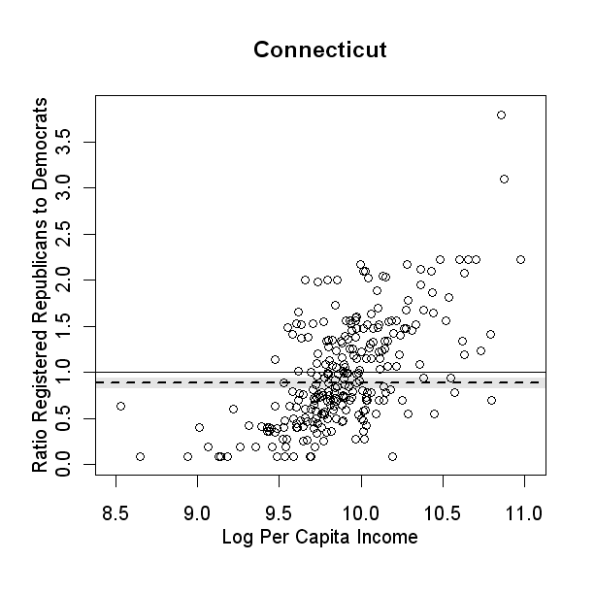

In this case I assigned voting data directly to zip code data, so multiple zip codes have the same voting data. The results are still fascinating I think. The next extension is to color dots by county (say just Fairfield or just Litchfield or the most liberal county) and/or identify towns of interest. I might try to do this by tonight just because I need to learn/remember how to use text as data points the same way G does to great effect.

## Put Most Recent TNC Comments Here:

# 

1. For instance, they claim that availability bias leads journalists – who reside disproportionately in wealther regions of the country – to see a trend in rich voters becoming more liberal (i.e. Bourgeois Bohemians) (pg xxx). Alternatively, they claim that partisans are more likely to believe themselves, and the country, to be doing better economically under a President of their own party and worse under a President of the other party.
2. To be fair, a fairly complicated and surprisingly consistent set of findings show a shift in the likelihood that rich and poor voters in rich states and poor states would vote for George W. Bush.
3. See Huckfeldt (200?), Mutz (200?) and Knoke (?) for examples of new network analytic approaches to citizen politics. Literature discussing the role of local politics in shifting the policy platforms of national elections stretches back to Clark (xxxx) and the emergent importance of the New Political Culture.
4. At the same time, Lieberman split sharply from the group following the 2001 publication of “Defending Civilization: How Our Universities Are Failing America and What Can Be Done About it” which printed a litany of what they believe to be anti-American reactions from within academia to the events of 9/11/2001.
5. It should be noted that the residents of Westport were not uniformly pleased with her commercial ventures, as Stewart (2000) and others (xxxx xxx) have written.
6. Specifically, analyzing all counties in the United States, the effect of Traditionalism and Localism are minor on the relationship between per capita incomes and voting patterns. Grouping counties by states reveals a varying but stronger effect, and analyzing Connecticut’s towns shows even stronger and geographically specific effects.
7. Even the National cross-section of the National Annenberg Election Survey of 2000 would have a bit more than 100 respondents per county on average. Regardless, we plan to determine the potential representativeness of this sample for performing a follow-up to these initial analyses. Beck et al. (2002) give serious pause that any of our findings should be taken too seriously without some kind of survey confirmation.
8. The alternative possibility would be to analyze the 2004 or 2008 Presidential Elections, using 2000, 2004 and 2008 CBP data and we intend to proceed down this path in future research.
9. A cursory examination of Martha Stewart’s Omnimedia will uncover that, on average, her audience is also highly educated. For our purposes, education is not considered a factor since we have no theoretic reason to expect education to directly impact how receptive women might be to her vision, nor how much time women might have available to enact this vision. One possibility is that class-status homiphily in marriages will tend to create family situations where women are not required to join the labor force.
10. The Martha Stewart Index is defined thusly via Census 2000 demographic variables

 $Martha Stewart Index=\frac{p044008+p044013+p044018+p044028+p044029}{p044001}+\frac{p050065+p050067+p050071}{p050049}$

   This represents the sum of two proportions. The first is the proportion of families (married or female-headed) where the woman is unemployed or not in the labor force. The second is the proportion of women (age 16 and over) who are employed in education, training and library occupations or as healthcare practitioners, technicians or other support occupations.
11. One might also describe these individuals as tending to live in rural areas, but Gimpel and Karnes (2006) use the National American Electoral Studies to launch a blistering critique of treating rural voters as *a priori* ignorant of their own economic well-being.
12. See Appendix for a table of correlations for vote share and Scenes, from 1992-2008. While it represents patterns among N ~ 3000 counties in the United States, it also illustrates that there is some reason to believe our choices are correct.
13. Included in this list are ‘Other’ and a 24th category ‘Not Applicable’ – the latter was ignored for our purposes.
14. See Patillo-McCoy (1999) Chapter 1 for an extensive discussion of the issues surrounding the identification of an African American middle-class for analysis.
15. For a recent review of this work, see McClain et al. (2009).
16. We can’t discount that this exceptional situation might occur, but we expect that calculation of the Index of Dissimilarity from Census Tract data should capture a great deal of natural clustering due to segregation.
17. Without this constraint, which is admittedly arbitrary, distributional characteristics of the Index of Dissimilarity as well as the Black Middle Class were tremendously non-linear, almost approaching binary in some cases. This threshold removes most of these problems, also guaranteeing that a non-negligble African American voting population exists.
18. Note: “Thus, indexes of dissimilarity for metropolises with small black populations may be compared to those for locations with many blacks. However, if mean indexes of black-white segregation are intended to describe the typical extent of segregation for blacks, these indexes should be weighted by the relative size of the black population”
19. **“**Gross rent as a percentage of household income in 1999 is a computed ratio of monthly gross rent to monthly household income (total household income in 1999 divided by 12). The ratio is computed separately for each unit and is rounded to the nearest tenth. Units for which no cash rent is paid and units occupied by households that reported no income or a net loss in 1999 comprise the category ‘‘Not computed.’’” (Census Technical Documentation, Summary File 3)
20. Gelman Standard: In 2000/2004, Bush vote of 55% or higher meant Republican, 45% or lower meant Democrat